TEAM PROJECT REPORT

RET Project: Air Quality Monitoring Near a Major Roadway

Submitted To
The 2018 RET Site

For
“Engineering Design Challenges and Research Experiences
for Secondary and Community College Teachers”

Sponsored By
The National Science Foundation
Grant ID No.: ECC-1710826
College of Engineering and Applied Science
University of Cincinnati, Cincinnati, Ohio

Prepared By
Participant #1: Marie Pollitt, Science, 8th Grade, Felicity-Franklin Middle School, Felicity, Ohio
Participant #2: Dean Stocker, Physics, Introductory College, University of Cincinnati Blue Ash College, Blue Ash, Ohio

Approved By
___________________________________________________
Dr. Sivaraman Balachandran
Assistant Professor, Environmental Engineering
Department of Chemical, and Environmental Engineering (ChEE)
College of Engineering and Applied Science
University of Cincinnati

Reporting Period: June 11-July 27, 2018
Abstract
Exposure to fine particulate matter (PM_{2.5}) has been linked to adverse health effects, especially for those living within city limits. The residents of Camp Washington (a neighborhood of Cincinnati, Ohio) have a life expectancy of 67 years, which is the fourth lowest in Cincinnati. The neighborhood is located between a major highway and a major rail switch yard (railyard). The focus of the research was to understand spatial and temporal variation of PM_{2.5} and also black carbon (BC), which is an important constituent of PM_{2.5}, in Camp Washington. Using real-time portable air pollution monitors and sensors, an extensive field campaign of Camp Washington was undertaken. Personal exposure to air pollution was measured during peak rush hour traffic times by using two means of transportation: walking and driving. The researched concluded there is a considerable spatial variation in PM_{2.5} and BC as well as significantly higher concentrations in the mornings compared to the afternoons. Furthermore, the BC concentrations are higher in the southern part of the neighborhood which is where the closest part of railyard is located. Additional research is needed to determine if the railyard is the majority contributor to air pollution in that area.
Key Words
Air pollution, black carbon, particulate matter, PM_{2.5}, urban neighborhood, major roadway
Main Body
- INTRODUCTION

There are many sources of pollutants such as industrial processes, transportation, agriculture activity, trading activity, and residences. Pollutants released from these sources are particulate matter (PM), carbon monoxide, nitrogen dioxide, lead, and sulfur dioxide. The Clean Air Act was established in 1970 to control air pollution in the United States. Since being enacted, major revisions were made in 1977 and 1990. These revisions were initiated because the “existing standards were not adequate to protect public health and the environment” (“Criteria Air Pollutants” 2018). Once such revision came about due to scientific evidence of health related effects from exposure to fine particulate matter (PM_{2.5}).
Particulate matter (PM) is an airborne mixture of small, solid particles and liquid droplets. PM originates from construction sites, unpaved roads, fields, smokestacks, fire plants, power plants, vehicles, and industries (Particulate Matter (PM) Pollution 2018). PM ranges in size from large enough to been seen with the naked eye (PM₁₀) to microscopic (PM_{2.5}). PM₁₀ has a diameter of 10 micrometers and smaller; mold, pollen, and dust fall within this size range. PM_{2.5} has a diameter of 2.5 micrometers or smaller; combustion particles, organic compounds, and metals are examples of particles that can fall within this size range. According to the Environmental Protection Agency (EPA), “The average human hair is about 70 micrometers in diameter – making it 30 times larger than the largest fine particle” (Particulate Matter (PM) Pollution 2018). Elemental carbon, also referred to as black carbon (BC) if measured optically, is an important component of PM_{2.5}.
Although there are many environmental regulations, dangerous BC is released into the environment; for example, near roadways and railyards, primarily due to incomplete combustion of fossil fuels, biofuels, and biomass. When PM _{2.5} is inhaled, it can cause serious health problems such as cardiovascular problems, lung and heart disease, upper respiratory issues, and premature death.
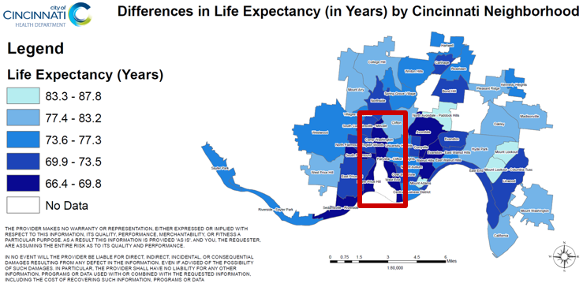
Camp Washington, Ohio is nestled between two major pollution sources, I-75 (roadway) and the CSX railyard. This neighborhood has the fourth lowest life expectancy in Cincinnati, see Fig. 1.To determine if PM_{2.5} from the major roadway contributes to this reduced life expectancy, the Southwest Ohio Air Quality Agency (SWOAQA) placed a near roadway (NR) site in the northern part of Camp Washington. The site is overseen by Hamilton County Department of Environmental Services. They are responsible for permits, enforcement, monitoring, and analysis related to air quality. The monitoring and analysis section conducts ambient air sampling in four counties, providing the area with air quality index, air quality advisory, and pollen and mold counts. Due to the site being a fixed location, data has not been collected throughout the neighborhood to determine the impact from the roadway and railyard pollution. The “Research Experience for Teachers” (RET) team created a plan for sampling, collecting, and analyzing PM_{2.5} and BC in the Camp Washington area.
Figure 1: Life Expectancies in Years by Cincinnati Neighborhood (“Neighborhood Life Expectancy Data,” n.d.)
- LITERATURE REVIEW

Exposure to fine particulate matter (PM_{2.5}) from traffic-related air pollution is linked to exacerbation of asthma, onset of childhood asthma, non-asthma respiratory symptoms, impaired lung function, total and cardiovascular mortality, and cardiovascular morbidity (Janssen et al. 2011; HEI 2010). According to National Ambient Air Quality Standards (NAAQS) put into place by the Environmental Protection Agency (EPA), PM_{2.5} is not to exceed 12 μg/m³ for primary annual mean average over three years, see Table 1. Although PM_{2.5} is a heterogeneous mixture, not all components contribute equally to health effects. PM_{2.5} deriving from “combustion-related particles are thought to be more harmful to health than PM that is not generated by combustion” (Janssen et al. 2011; Krzyzanowski et al. 2005, WHO 2007). A study conducted by Janssen et al. (2011) examined the value of black carbon (BC) which is a component of PM. The results from the investigation yielded a 1-μg/m³ increase for black carbon particles (BCP) compared to PM₁₀ and PM_{2.5}. It concluded “the estimated increase in life expectancy associated with a hypothetical traffic abatement measure was four to nine times higher when expressed in BCP compared with an equivalent change in PM_{2.5} mass” (Janssen et al. 2011).

Table 1: National Ambient Air Quality Standards
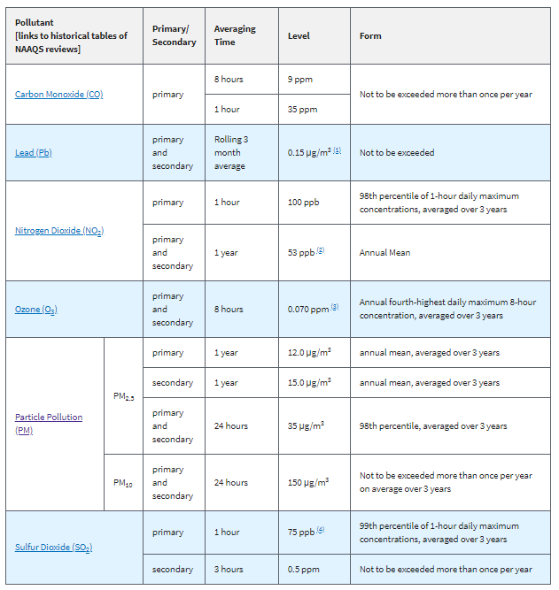
Many advances in techniques to measure air pollution have occurred; for example, “satellite remote sensing (RS), chemical transport models (CTMs), land-use regression (LUR) models, and direct exposure measurements” (Apte et al, 2017). Camp Washington currently has a conventional fixed monitoring site, or a near-road (NR) site, located at the corner of Arlington and Colerain and adjacent to a major roadway (I-75). This site measures the pollutants presumably emitted by traffic from the major highway. According to Baldauf et al. (2009), “these elevated concentrations generally occur within a few hundred meters of the road; however, this distance may vary depending on the traffic patterns, environmental conditions, topography, and the presence of roadside structures” (Baldauf et al. 2009).
Air pollution varies drastically over short distances; therefore, additional methods of air sampling are needed in order to get real-time air pollution data within the neighborhood. A study conducted in Oakland, California by Apte et al. (2017) investigated the use of Google Street View vehicles to map urban air patterns. The sampling lasted from May 28, 2015 to May 14, 2016 and sampling began at 9:00 AM and was conducted six to eight hours a day during the weekdays. The study area included three main areas: downtown Oakland, East Oakland, and West Oakland. The route included major interstate highways, container port, rail and trucking facilities, as well as industrial and residential areas. The study revealed “persistent pollution patterns with surprisingly sharp small-scale variability attributable to local sources, up to five to eight times within individual city blocks” (Apte et al. 2017).
One study completed in Bogota, Colombia by Morales Betancourt et al. (2016) examined commuters’ intake dose of PM_{2.5}, BC, and sub-micron particles. Although commuters in motorized modes were exposed to higher concentrations than pedestrians and bicyclists, the study suggested that pedestrians experienced at least 50% higher PM intake compared to public transport buses. The rationale was “slower travel speed and elevated inhalation rates dominate PM dose for pedestrians” (Betancourt et al. 2017).
- GOALS AND OBJECTIVES

The goal of the research was to develop a sampling plan to determine how air pollution generated on a major roadway and railway impacted an adjacent neighborhood. The pollution being measured during the investigation was fine particulate matter (PM_{2.5}) and black carbon (BC). In order to achieve this goal, the “Research Experience for Teachers” (RET) team needed to familiarize themselves with the instruments being used: microAeth® AE51, DustTrak ™ II, and a GPS logger. Analysis was performed with the following software: Matlab, Excel, AETH lab, and Google maps.
- RESEARCH STUDY DETAILS

The focus of this research project was to gain a better understanding of pollutant concentrations as well as how they vary spatially and temporally in Camp Washington. Prior to creating a sampling plan, the “Research Experience for Teachers”(RET) team needed to find an approach to how sampling was going to take place. For example:
- How was the team going to collect data (stationary, walking, driving, or biking)?
- What type of areas should be sampled (railyard, roadway, commercial, residential)?
- How much of Camp Washington should be sampled (north, south, Hopple Street)?
Preliminary data was collected in Camp Washington and analyzed as part of training to learn how the instruments work (see Fig. 2). As part of this process, the RET team determined there should be two sampling routes: driving and walking during AM and PM rush hour traffic, see Fig. 3. The driving loop allowed for sampling in multiple land use areas and in the community. The route included the EPA monitoring station, construction sites, mixed residential and commercial areas, I-75 (major roadway), and commercial areas near the railyard. The walking route included residential, commercial, and mixed-use areas. Both routes were sampled simultaneously from 7:00 AM to 8:30 AM and from 4:00 PM to 5:30 PM on weekdays from 26 June 2018 through 12 July 2018.
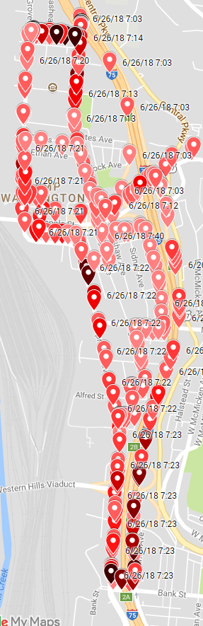
Figure 2: Preliminary data along a driving route. The darker symbols represent higher concentrations of PM_{2.5}.
Figure 3: The blue line shows a portion of the driving loop, while the red line shows the walking loop.
4.1 Instruments Used
4.1.1 PM_{2.5}
Two DustTrak™II Model 8530 aerosol monitors (one is shown in Fig. 4) were used to measure the concentration of PM_{2.5}. These monitors operate by drawing air through the attached tube and measuring the amount of light scattered by the particles in the air as it moves through the monitor. The flow rate for the monitor was set to 3 liters per minute.

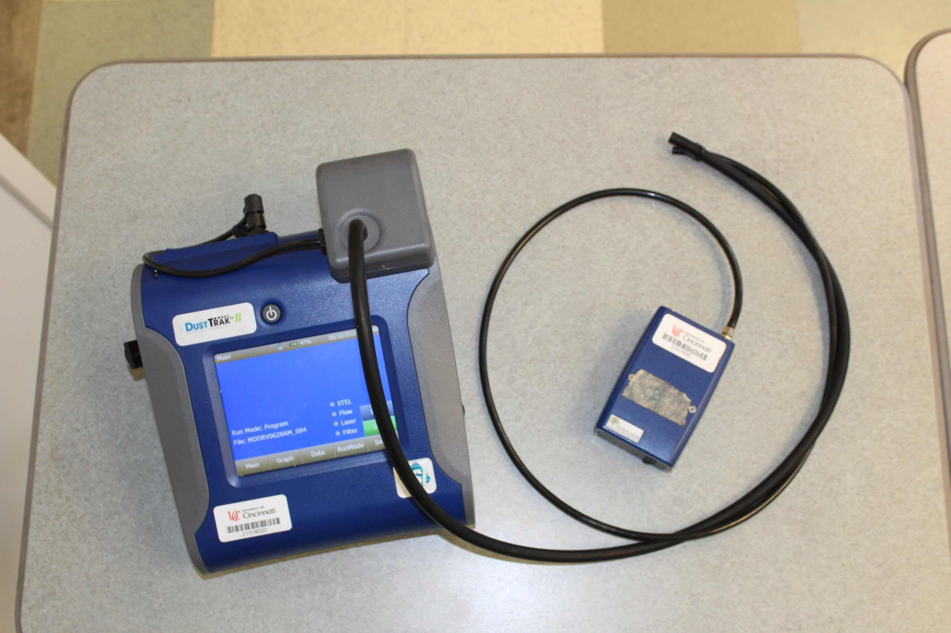
Figure 4: DustTrakTM II (left) and microAeth® AE51 (right), with hoses tied together at the end to collect air samples from the same location.
4.1.2 Black Carbon
Two MicroAeth® AE51 Real-time Aerosol Black Carbon Personal Exposure Measurement Devices (one is shown in Fig. 5) were used to measure the concentration of black carbon. These devices operate by drawing air through the attached tube and passing it through a filter strip consisting of a T60 Teflon coated borosilicate glass fiber media. A laser is used to measure the attenuation of light as it passes through the filter to determine the concentration of black carbon. The flow rate for the device was set to 0.15 liters per minute.
4.1.3 GPS Location
In order to correlate PM2.5 and BC data with various locations in the neighborhood, a GPS tracker was used. There is a free “GPS Logger” app available for Android smartphones (see figure ****), that produces comma-separated-variable (CSV) files which can then be imported into Excel or MatLab for analysis. Details about this app can be found at https://play.google.com/store/apps/details?id=eu.basicairdata.graziano.gpslogger&hl=en_US.
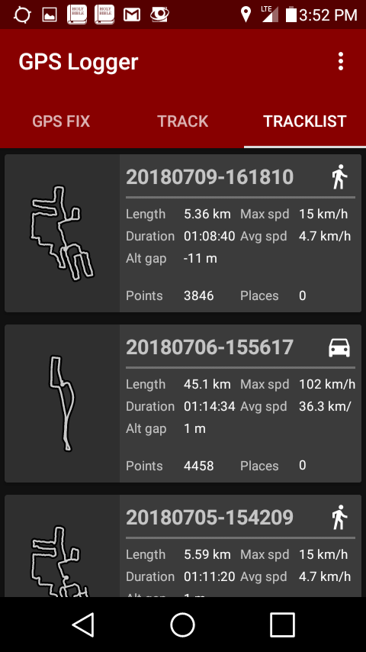
Figure 5: Screenshot from a smartphone running the GPS Logger app
that was used to correlate data to specific locations in Camp Washington.
4.2 Colocation of Instruments
Comparison measurements needed to be made between the two sets of instruments to ensure that data collection was consistent regardless of which specific set of instruments was being used. This was done by colocating the instruments: collecting data for several minutes with the ends of all of the collection tubes tied together so that all instruments were sampling air at the same location.
4.3 The Campaign
Data was collected along the walking and driving loops described earlier. For data collection while driving, the instruments were placed inside the car with the windows rolled up and the hoses protruding from the window, see Fig. 6. For data collection while walking, the instruments were placed in a backpack with the hoses left out of the top, see Fig. 7. Data was collected along both routes simultaneously from 7:00 AM to 8:30 AM and from 4:00 PM to 5:30 PM on weekdays from 26 June 2018 through 12 July 2018 with a few exceptions: sampling was not done on 4 July because there was no “rush hour” on the holiday; sickness prevented collecting data on the morning of 12 July; and rain prevented collecting a complete data set on the afternoon of 3 July.

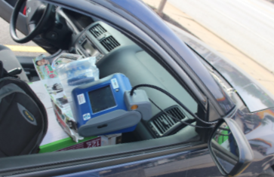
Figure 6: DustTrakTMII and AE51 (inside the plastic air bags) inside the car with the hoses protruding. In this photo the window is rolled down, but during data collection the windows were rolled up except for a gap just large enough for the hoses.

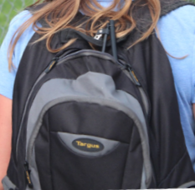
Figure 7: DustTrakTMII and AE51 inside the backpack with the hoses protruding.
Data was logged once per minute on the walking loop and once every ten seconds on the driving loop. Since walking speeds are typically around 5 km/h, this means that one data point was logged approximately once every 80 meters while walking. The average driving speeds on the loop through and around Camp Washington were approximately 40 km/h, so one data point was logged approximately once every 110 meters while driving. However, the maximum speeds on the driving loop sometime reached 100 km/h, making data points on the interstate sometimes almost 300 meters apart.
Some of the streets where the team collected data are less than 100 meters long, so often data was logged a relatively large distance away from the area where it was actually collected. In order to position data on the map closer to the area where the data was actually taken, logged data was mapped to four different locations, as described in Fig. 8. The four locations were determined based on the GPS position of the previously logged data and the GPS position of the newly logged data. The mapped data was spatially averaged using Matlab, with a resolution of 50 meters, and overlaid on a Google Map of the neighborhood.

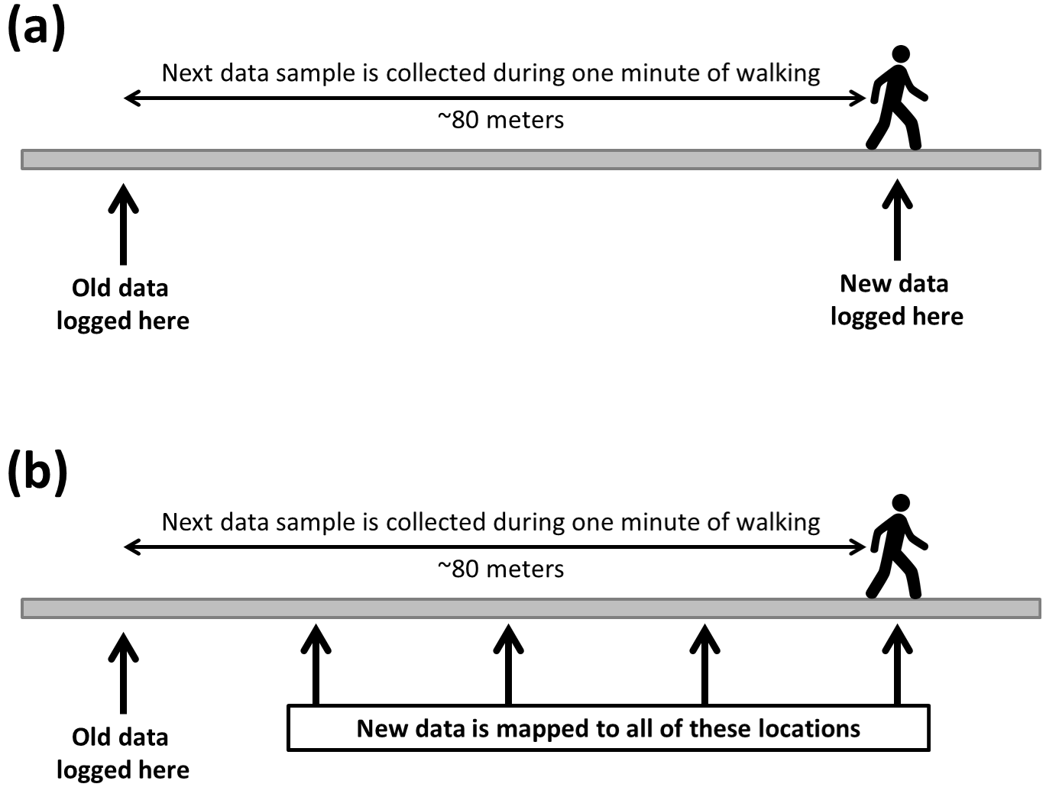
Figure 8: In order to position the mapped data closer to the location where it was actually collected, the logged data was mapped to four different locations equally spaced along the route that was traveled since the last time the data was logged. Part (a) of the figure shows where the data is collected and where it is logged without an attempt at mapping the data to the route traveled. Part (b) shows the four different places where the newly logged data has been mapped into the data sets presented in the results section of this paper.

- RESEARCH RESULTS

5.1 Colocation of Instruments
Colocation results for the DustTrakTMII PM_{2.5} monitors are shown in Fig. 9. One monitor was operated with a 10-s sample rate (to be used while driving) and the other with a 60-s sample rate (to be used while walking), and this data is represented by the solid lines. The baseline levels for these two lines are roughly the same, but there are large spikes in the 10-s data. To ensure that both detectors were operating correctly, the 10-s data was averaged out to 60 seconds, represented by the dashed line in the figure. This comparison shows that the large spikes in the 10-s data corresponded well to the smaller spikes in the 60-s data. The difference in concentration measurements between these two devices was found to be 6%, with the monitor used to collect 10-s data reading a larger concentration than the monitor used to collect 60-s data.

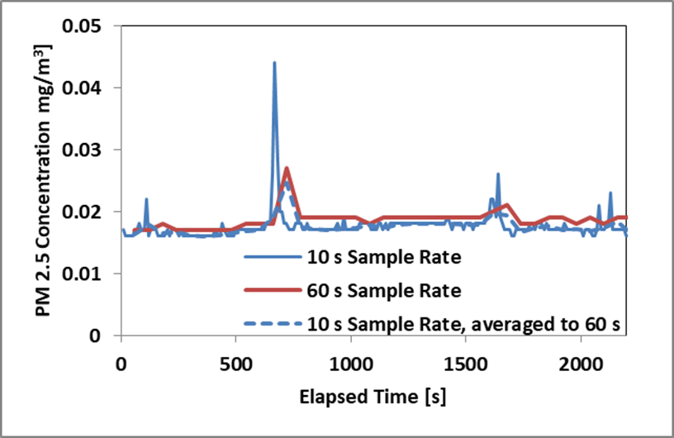
Figure 9: Colocation of DustTrak TM II monitors. One monitor was operated with a 10-s sample rate and the other with a 60-s sample rate, and the data is represented by the solid lines. The dashed blue line represents the 10-s data averaged out to 60 seconds.
The first time an attempt was made at colocating the MicroAeth® AE51 BC devices, it was observed that the data was not reliable when the sample rate was set to 10 seconds. As can be seen in Fig. 10 the data was noisy and often gave negative values for the concentration of BC in the air.

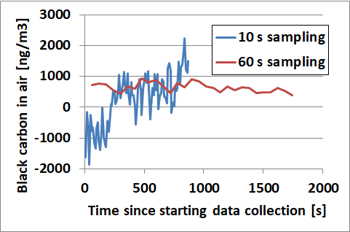
Figure 10: Erratic (noisy) data measurements from an AE51 black carbon device operating with a 10-s sample rate.
According to the manual for the AE51, it can be susceptible to vibration, especially at fast sample rates. In an effort to improve the quality of the data, the AE51 with the 10-s sample rate was padded using air bubble packets of the type often used as packaging to protect items that are sent through the postal service. This reduced the noise considerably, as can be seen in Fig. 11. With the addition of this padding, reliable results were achieved at a 10-s sample rate.

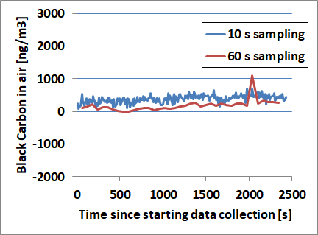
Figure 11: Data measurements with padding added for the AE51 operating with a 10-s sample rate.
New colocation results for the AE51 devices, after padding was added, are shown in Fig. 12. One device was operated with a 10-s sample rate (to be used while driving) and the other with a 60-s sample rate (to be used while walking), and the data was post-processed using AETHlabs software on the Aethlabs website, https://aethlabs.com/node/add/data-file, using the “ONA algorithm” smoothing with an ONA ATN threshold value of 0.05 (Gayle et al. 2011). This algorithm smooths the data as observed in Fig. 12, with the algorithm determining the times when the BC level was not changing and averaging all data in that time frame to reduce statistical variation in the data. The difference in concentration measurements between these two devices was considerable, with the device used to collect 60-s data reading a concentration 33% lower than the device used to collect 10-s data. In the time frame of this project we were unable to colocate these devices with a recently calibrated device, so we scaled the 10-s data down by a factor of 33% to keep the devices consistent with one another.
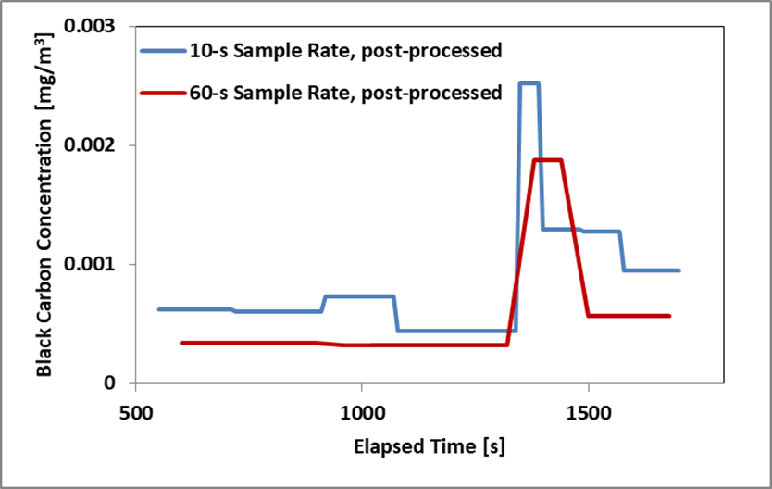
Figure 12: Colocation of MicroAeth® AE51 devices, with post-processed data. One device was operated with a 10-s sample rate and the other with a 60-s sample rate.
5.2 The Campaign
5.2.1 Comparison of Driving vs Walking loops and Mornings vs Afternoons
Data was initially compiled into four sets: data collected while walking during morning rush hours (Walking AM), data collected while driving during morning rush hours (Driving AM), data collected while walking during evening rush hours (Walking PM), and data collected during evening rush hours (Driving PM). Box-and-whisker plots of these four sets of data are shown in Fig. 13 for PM_{2.5} and Fig. 14 for BC.

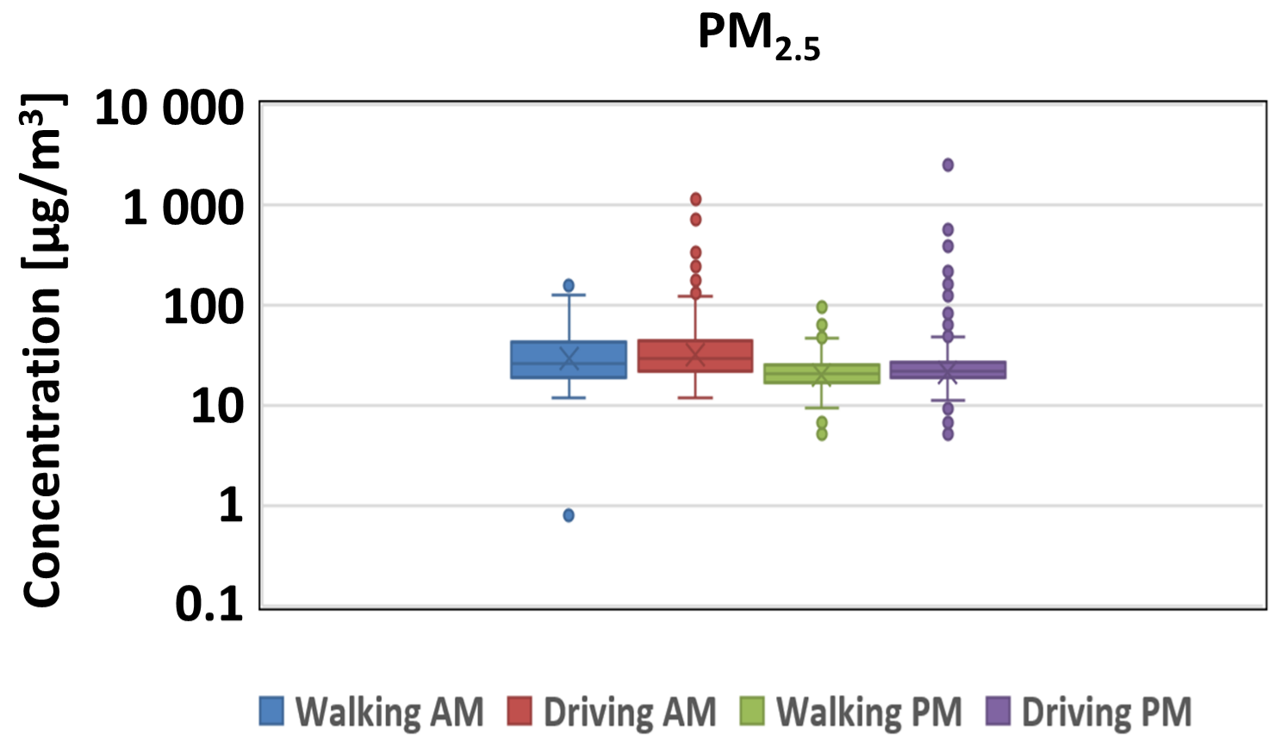
Figure 13: Box and whisker plot of all PM2.5 data that was collected. Note that the concentration is on a logarithmic scale because of the large variation in the values of the data.
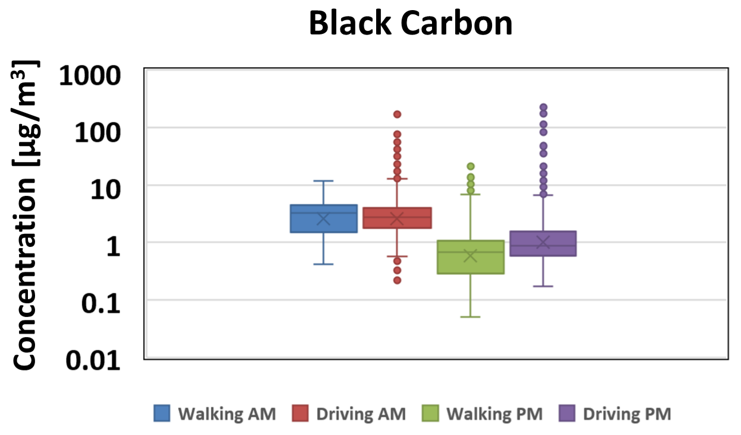
Figure 14: Box and whisker plot of all PM2.5 data that was collected. Note that the concentration is on a logarithmic scale because of the large variation in the values of the data.

Statistical analysis was done to determine which sets of data were statistically different from one another. The t-test results are shown in Table 2 for PM_{2.5} and in Table 3 for BC. The t-test results show that the difference in concentrations between morning and evening is statistically significant, but the difference in concentration between the driving loop and the walking loop is not statistically significant.

Table 2: t-test results (two-sample assuming equal variances) of PM2.5 data. Columns and rows were chosen such that similar data could be compared. Each cell represents either a comparison of the same collection area at two different times of day or a comparison of two different collection areas at the same time of day.
PM_{2.5} | AM Walking |  | PM Driving
AM Driving | T statistic | -1.76 | T statistic | 10.81
 | t crit (two-tailed) | 1.96 | t crit (two-tailed) | 1.96
 | Statistically significant difference? | NO | Statistically significant difference? | YES
PM Walking | T statistic | 10.99 | T statistic | -1.46
 | t crit (two-tailed) | 1.96 | t crit (two-tailed) | 1.96
 | Statistically significant difference? | YES | Statistically significant difference? | NO

Table 3: t-test results (two-sample assuming equal variances) of BC data. Columns and rows were chosen such that similar data could be compared. Each cell represents either a comparison of the same collection area at two different times of day or a comparison of two different collection areas at the same time of day.
BC | AM Walking |  | PM Driving
AM Driving | T statistic | -1.64 | T statistic | 7.00
 | t crit (two-tailed) | 1.96 | t crit (two-tailed) | 1.96
 | Statistically significant difference? | NO | Statistically significant difference? | YES
PM Walking | T statistic | 14.15 | T statistic | -2.84
 | t crit (two-tailed) | 1.96 | t crit (two-tailed) | 1.96
 | Statistically significant difference? | YES | Statistically significant difference? | NO

5.3.5 Combined data
Since the t-tests show that the driving data is not significantly different from the walking data, these data sets could be combined to form separate maps for AM and PM. However, with the current data sets there was not sufficient data to get high-resolution maps for AM and PM separately. Therefore, data sets for morning, afternoon, walking, and driving were all combined to form a single data set. Maps for PM_{2.5} and BC are both shown in Fig. 15.

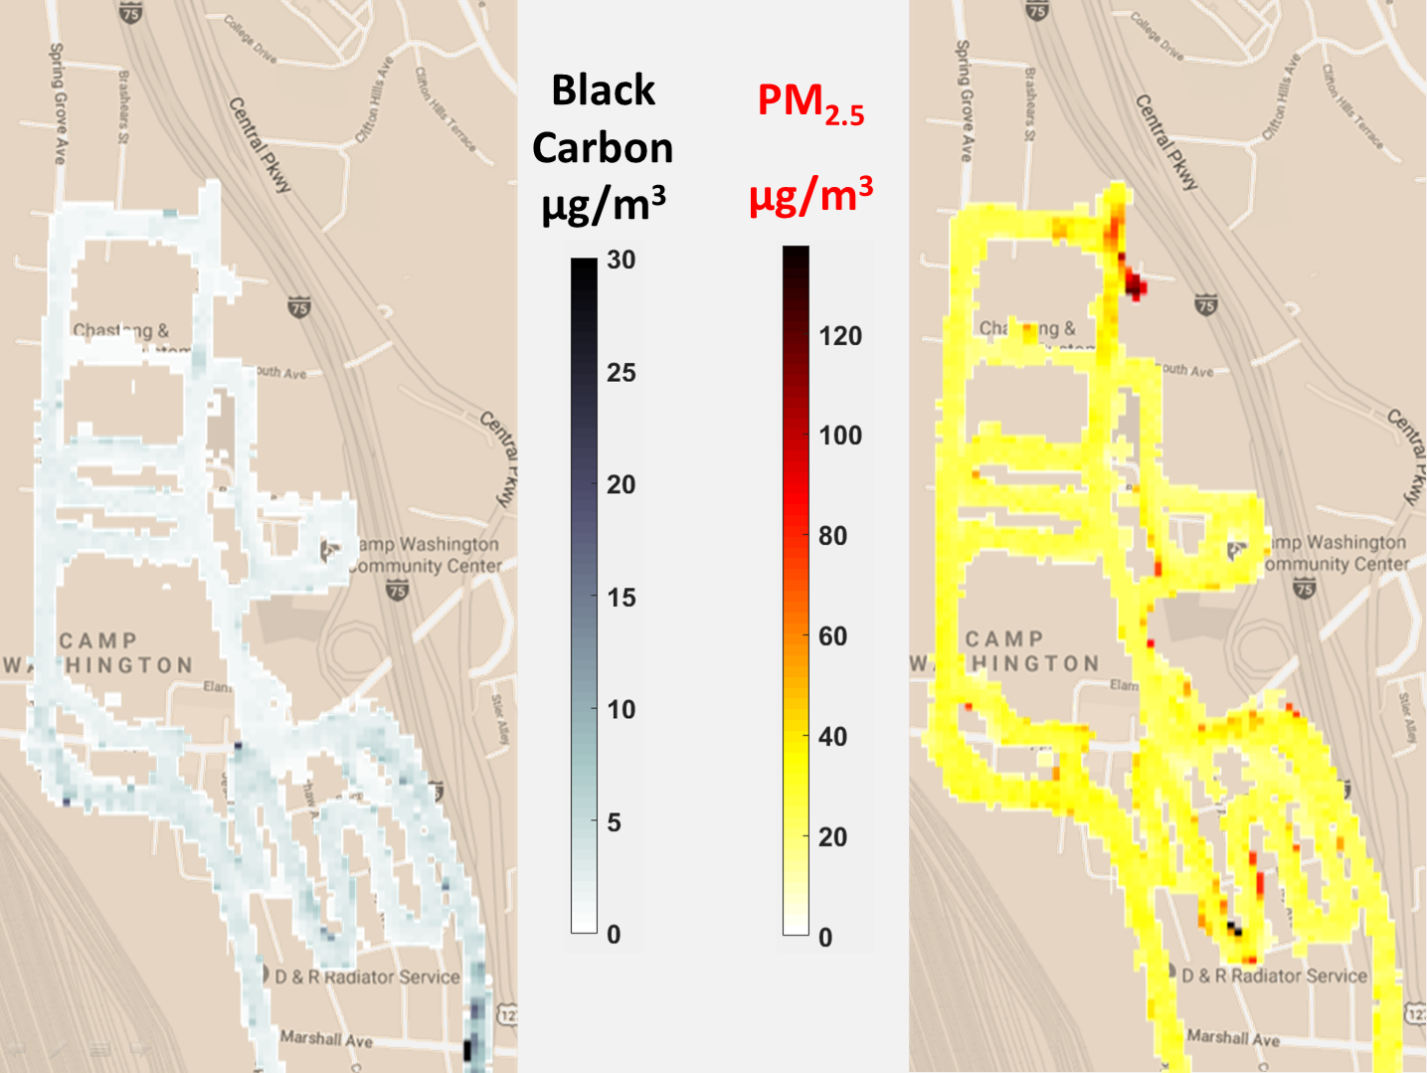
Figure 15: Average black carbon and PM2.5 concentrations in the Camp Washington neighborhood.
The BC concentrations appear to be generally higher when you are in the southern part of Camp Washington, starting around Hopple Street, which is the major East-West roadway through the neighborhood. On the interstate (the lower right side of the maps), some heavy concentrations of BC were measured, especially in places where occasional clouds of black smoke coming from large diesel vehicles were encountered.
There are a few “hot spots” in the PM_{2.5} map. The one at the top right is at a large dirt pile near a construction site. Heavy vehicles were often working in the area and leaving dust on the roadway, which was then kicked up every time a vehicle drove past. There are also a few smaller hot spots in the southern part of Camp Washington where there is a large concentration of various small industrial companies.

- RESEARCH CONCLUSIONS

There is considerable spatial variation in the concentrations of fine particulate matter (PM_{2.5}) and black carbon (BC) in Camp Washington. The concentrations of PM_{2.5} and BC are higher in the mornings than in the afternoons. This is expected because the “mixing layer” is smaller in the morning and gets larger as the day progresses.
The BC concentration is higher in the southern part of Camp Washington.There are at least two possible reasons for this. First, there is a large concentration of various small industrial companies in this area, and they could be producing BC. Second, at the southern end of Camp Washington the railyard is much wider, which could mean that more BC is produced there, and the distance between the railyard and I-75 is smaller in the southern end of Camp Washington than in the northern end. Roadway effects are mostly observed only within about 200 meters of the roadway (Apte et al. 2017), and in its southern section of Camp Washington is only about 400 meters wide, meaning that all parts of the neighborhood are within 200 meters of either the railyard or the interstate. The concentration of PM_{2.5} does not show such a strong trend from north to south, but has hot spots in isolated locations that seem to be associated with construction or industry.
- RECOMMENDATIONS FOR FUTURE RESEARCH

As is typical for most research, as this study progressed it became clear that there is room for improvement in the way the data is collected and analyzed, and many related topics worthy of study have also been identified along the way. Some of the results from this report will be reported at the 10th International Aerosol Conference which takes place in St. Louis, Missouri, in September 2018. The following are some suggestions for future research that will build upon the work that is reported here:
More data collection in Camp Washington would result in more reliable statistics, so this study could be simply extended by spending more time collecting data, or by combining it with data sets that have already been collected by others within the same research group. Some potential changes to the way data is taken in this study could include:
- Starting the walking loop in varied locations, so the data is not always collected first North of Hopple Street and then South of Hopple Street. This would help to ensure that spatial variation is not correlated with temporal variation.
- Varying the paths to include more of the roads in Camp Washington.
- Including other times of day instead of just rush hour.
The instruments could be colocated with the Southwest Ohio Air Quality Agency (SWOAQA) near roadway (NR) site in Camp Washington. The NR instruments are accurately calibrated on a regular basis and would provide an easy way to ensure that the DustTrak’s and AE51’s are also calibrated properly.
More analysis can be done on the current data set.
- An ANOVA test should be performed to help determine the sources of any statistically significant differences.
- The mapping of the concentration data to the latitude and longitude can be done in such a way that data is mapped only onto the paths that were traveled and not spread into adjacent areas.
- A program such as ArcGIS (http://www.arcgis.com/index.html) can be used to plot the data so it can easily be divided into various regions (interstate, major artery, residential road, etc.) to allow more careful comparison of the different areas.
Stationary monitoring sites can be set up around the neighborhood or around the railyard and interstate. This would help to determine the sources of PM_{2.5} and BC, and would allow easy correlations with prevailing wind and other weather conditions and with time of day.
- CLASSROOM IMPLEMENTATION PLAN

8.1 Dean Stocker’s Classroom Implementation Plan
The unit titled Physics is Everywhere will be implemented in an introductory physics class at a two-year college. This will be a term-length unit, being introduced even before the first day of class and ending with group presentations on the last day of class.
There will be a pre-first-class-survey asking how physics is related to the students' lives. Relevant survey questions include: “Why are you taking this course?” “If your degree program requires you to take this course, why are you in that program, and why do you think that program requires you to take this course?” and “What is one way that you believe physics may be relevant to something that you do on a daily or weekly basis?”
In the 2nd week of class, after we have done a brief overview of the topics that will be covered in the class (motion, forces, momentum, and energy), students will be asked again to consider how physics relates to something relevant to their lives. Students will be presented with a generic essential question, “How is physics related to something I care about?” and then create specific essential questions that are relevant to themselves personally, for example, “What physics is involved in running a marathon?” Groups will be formed among students who are interested in studying each of several specific essential questions.These chosen topics will be woven through the remainder of the term, with students making specific applications to their chosen topics as new ideas are introduced in the course content.
Over the course of the term, the applications the students find will be recorded in engineering notebooks, and the groups will develop a plan for how they can take data related to their chosen topic. They will be encouraged to use smartphone apps and/or the free software “Tracker” (https://physlets.org/tracker/). The students will learn to analyze data and present it graphically.
At the end of the term, there will be final presentations where the teams present their findings about how physics is relevant to their chosen topics. There will be a practice run two weeks before the end of the term where the teams will receive feedback from their peers about which parts of their presentation were well done and where improvements could be made. The peer reviews will be based on the same rubric that will be used to grade the final project, covering such areas as content, oral presentation, text, organization, and visual design of the presentation. The groups will then have two weeks to make changes, which could include re-taking or re-analyzing some of their data, before giving their final presentations in the last week of the term.
8.2 Marie Pollitt’s Classroom Implementation Plan
The unit titled Environmental Remediation will be implemented in an eighth grade classroom. Prior to being introduced to the topic, students will take a field trip to a floating classroom orchestrated by Living Lands and Waters which will be docked on Ohio River in Ripley, Ohio. They will participate in two hands-on learning activities: Biological Magnification and Eyes on Invasions. The objective is to learn about the value of clean water, waste reduction, and recycling. Following the field trip, students will be introduced to the big idea of Pollution and the Environment and a video clip. The clip will reveal the terrible fact that 10 billion pounds of unlined coal ash ponds are located at W.C. Beckjord Station which contains arsenic, mercury, sulfuric acid, lead, and many other toxins. Through a series of well constructed questioning strategies and activities, students will develop a common essential question such as, “how can we safely clean up the pollutants at a power plant?” After students are given an opportunity to brainstorm possible challenges they should arrive to one similar to “design a plan to safely clean up the ash ponds at Beckjord.” Students will develop a list of guiding questions that will help them solve the challenge. Prior to starting the engineering design process (EDP), students will collect, analyze, and graphically represent pollution (PM_{2.5} and Ozone) provided by the Air Quality Agency Ambient Air Monitoring Site in Batavia, Ohio. They will investigate the process of bioremediation, explain how engineers make sure bacteria have everything they need to help degrade harmful compounds, and gain experience with mass and volume measurements. Finally, they will identify the general characteristics of organisms that reproduce sexually, asexually, and both as well as the advantages and disadvantages of sexual and asexual reproduction. Students will research the different types of pollutants at a specific power plant (Beckjord). They will devise a plan that will use a living organism to remove one of the pollutants from the ash ponds. After the team agrees to which toxin the team wants to research, they will provide an overview of the organism being used, its reproductive process, positive and negative ramifications of introducing the species to the environment, as well as identify any mutations that may occur. Groups are responsible for providing a safety plan for proper disposal of the organism introduced to the environment. Upon reflecting on the process, students will create a sales pitch to the Environmental Protection Agency (EPA) discussing how their solution will help clean up the toxins left behind from operating the power plant. Students will provide feedback to their peers. After all students have presented and received feedback, they will be introduced to the “refine” portion of the EDP. The teams will be given the following situation: your company is unable to use the current organism for clean-up due to a shortage; therefore your company will need to provide an alternative solution to complete the job. Students will refine their work as well as make revisions based on the feedback received from their peers. A final presentation will take place and students will be evaluated on the content, slide organization, spelling/grammar, visual design, and oral presentation.
- ACKNOWLEDGEMENTS

The RET program, “Engineering Design Challenges and Research Experiences for Secondary and Community College Teachers, Grant ID# EEC-1710826.
Faculty Mentors: Dr. Sivaraman Balachandran, Dr. Mingming Lu
Graduate Research Assistant (GRA): Ms. Madhumitaa Roy
Field Research Team: Mr. Dexter Adams, Mr. Yajna Jathan, and Mr. Deshui Xu
RET Project Director and Principal Investigator, Dr. Anant Kukreti
RET Co_Project Director and Co-Principal Investigator, Dr. Margaret Kupferle
RET Resource Person and Grant Coordinator, Ms. Debbie Liberi
RET Resource Teacher, Pamela Truesdell

- BIBLIOGRAPHY

Apte, J. S., Messier, K. P., Gani, S., Brauer, M., Kirchstetter, T. W., Lunden, M. M., et al. (2017). "High-resolution air pollution mapping with google street view cars: Exploiting big data," Environmental Science & Technology, 51, 6999-7008.
Baldauf, R., Watkins, N., Heist, D., Bailey, C., Rowley, P., Shores, R., (2009). “Near-road air air quality monitoring: Factors affecting network design and interpretation data,” Air Quality, Atmosphere & Health, 2(1), 1-9.
Betancourt, R. M., Galvis, B., Balachandran, S., Ramos-Bonilla, J. P., Sarmiento, O. L., Gallo-Murcia, S. M., et al. (2017). "Exposure to fine particulate, black carbon, and particle number concentration in transportation microenvironments," Atmospheric Environment, 157, 135-145.
“Criteria Air Pollutants.” (2018). EPA, Environmental Protection Agency, <https://www.epa.gov/criteria-air-pollutants> (June 27 , 2018).
“Criteria Air Pollutants.” (2018). EPA, Environmental Protection Agency, <https://www.epa.gov/criteria-air-pollutants/naaqs-table> (July 20 , 2018).
Gayle, S.W., Yelverton, T., Vedantham, R., Hansen, A., Turner, J., (2011). “Post-processing method to reduce noise while preserving high time resolution in aethalometer real-time black carbon data,” Aerosol and Air Quality Research, 11(5), 539-546
HEI (2010). “Traffic related air pollution: A critical review of literature on emissions, exposure, and health Effects,” HEI Special Report 17. Boston: Health Effects Institute
Janssen, N. A., Hoek, G., Simic-Lawson, M., Fischer, P., van Bree, Ll, et al. (2011). “Black carbon as an additional indicator of adverse health effects of airborne particles compared with PM^sub10^ and PM^sub2.5^,” Environmental Health Perspectives, 119(12), 1691-1699.
Krzyazanowski, M., Kuna-Dibbert, B., Schneider, J., (2005). “Health effects of transport-related air pollution,” Copenhagen: World Health Organization.
“Particulate Matter (PM) Pollution.” (2018). Environmental Protection Agency, <https://www.epa.gov/pm-pollution/particulate-matter-pm-basics#PM> (July 7 , 2018).
WHO (2007). “Health relevance of particulate matter from various source,” Report on a WHO Workshop. Copenhagen: World Health Organization Regional Office for Europe.

- APPENDIX I: NOMENCLATURE USED

AE51 = microAeth® AE51 monitor
ANOVA = Analysis of Variance
ATN = incremental light attenuation
BC = black carbon
CBL = Challenge Based Learning
CSV = comma-separated-variable
CSX = Chessie Seaboard Consolidated
CTMs = chemical transport models
DustTra k = DustTrak II Aerosol Monitor 8530
EDP = Engineering Design Process
EPA = Environmental Protection Agency
GPS = Global Positioning System
GRA = graduate research assistant
km/h = kilometers per hour
LUR = land-use regression models
NAAQS = National Ambient Air Quality Standards
NR Site = Near Roadway site
ONA = Optimized Noise-reduction Averaging
PM = particulate matter
PM_{2.5} = particulate matter size 2.5 micrometers and less
PM₁₀ = particulate matter size 10 micrometers and less
RET = Research Experience for Teachers
RS = satellite remote sensing
s = seconds
SWOAQA = Southwest Ohio Air Quality Agency
UC = University of Cincinnati
km/h = kilometer per hour
mg/m³ = milligram per cubic meter
µg/m³ = micrograms per cubic meter

- APPENDIX II: RESEARCH SCHEDULE

Week 2: Training on instruments and analysis
Week 3: Development of test plan, validating data collection techniques
Week 3-5: Data collection
Week 5-6: Data analysis
Week 6: Finalize data and complete reports, posters, PPT, video

- APPENDIX III: UNIT PLAN FOR DEAN STOCKER

Name: Dean Stocker | Contact Info: dean.stocker@uc.edu | Date: 2018-07-23

Unit Number and Title: 1 Physics is Everywhere

Grade Level: | 1st yr college
Subject Area: | Intro Physics

Total Estimated Duration of Entire Unit: | Term-length project; intro first week, finish last week

Part 1: Designing the Unit
- Unit Academic Standards (Identify which standards: NGSS, OLS and/or CCSS. Cut and paste from NGSS, OLS and/or CCSS and be sure to include letter and/or number identifiers.):

Course Description (from course catalog)
Algebraic concepts in mechanics: motion, forces, momentum, and energy.
Also explore: properties of matter, heat, oscillation, and waves.

- Unit Summary

The Big Idea (including global relevance): Physics is everywhere
The (anticipated) Essential Questions: List 3 or more questions your students are likely to generate on their own. (Highlight in yellow the one selected to define the Challenge):
How is physics relevant to our lives?
How is conservation of energy relevant to our lives?
How is conservation of momentum relevant to our lives?
How is dynamics relevant to our lives?
How is kinematics relevant to our lives?

- Unit Context
Justification for Selection of Content– Check all that apply:
☐ Students previously scored poorly on standardized tests, end-of term test or any other test given in the school or district on this content.
☒ Misconceptions regarding this content are prevalent.
☒ Content is suited well for teaching via CBL and EDP pedagogies.
☐ The selected content follows the pacing guide for when this content is scheduled to be taught during the school year. (Unit 1 covers atomic structure because it is taught in October when I should be conducting my first unit.)
☒ Other reason(s) ___The students need to be able to relate the physics concepts we have been learning to applications in the real world, and particularly to their own lives.________

The Hook: (Describe in a few sentences how you will use a “hook” to introduce the Big Idea in a compelling way that draws students into the topic.)
There will be a pre-first-class-survey asking how physics is related to the students' lives.
Relevant survey questions:
- Why are you taking this course?
- If your answer to the last question was…
  - "…Because I have to take it for my program," why are you in that program, and why do you think that program requires you to take this course?
  - "…Because I love physics," what is your favorite thing about it?
  - …anything else, just type whatever you want for this one.
- What is one way that you believe physics may be relevant to something that you do on a daily or weekly basis?

In the 2nd week of class, I will display snippets of their answers along with associated pictures in a scrolling PowerPoint.

The Challenge and Constraints:

☐ Product or ☒ Process (Check one)

Description of Challenge (Either Product or Process is clearly explained below): | List the Constraints Applied
Find a way to clearly demonstrate how physical concepts are related to something you care about in your life.  Iteration: Make changes to your data collection techniques or data analysis that improve your results. | Work in groups of 2-4 people.  Must apply to your job, home, sports/hobbies, the environment, or transportation.  Must collect your own original data that demonstrate how physics applies to your chosen topic (I will recommend some apps to use)  Must include annotated sketches.  Must analyze your data and present it graphically.  Analysis must include to at least two of the following physics concepts:  - Kinematics  - Dynamics  - Momentum  - Energy  Must describe the importance of the chosen topic to their own lives and the lives of others.  Must list at least 3 careers in which people could benefit from being able to do this type of data collection and analysis.

Teacher’s Anticipated Guiding Questions (that apply to the Challenge and may change with student input.):
Note: This list of questions will be developed over the course of weeks as we are learning related material and they are exploring ways to collect the data they need.
How can we put these ideas together to actually solve a problem?
How do I know whether to use kinematics, dynamics, momentum, or energy?
What forces are we going to have to deal with?
What types of energy are we going to have to deal with?
What role does friction play?
Do I have to deal with acceleration?
Is this a 1-dimensional problem, or 2 or 3 dimensions?
Do I have to deal with rotation?
What reference frame should I be working in?
What can I use to collect data?
What is the best way to present the data graphically?

4. EDP: Use the diagram below to help you complete this section.
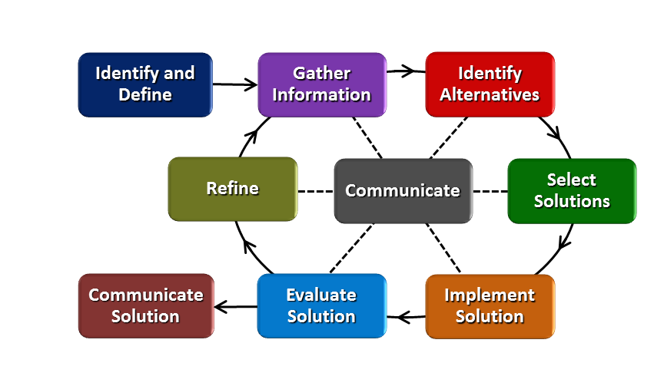
How will students test or implement the solution? What is the evidence that the solution worked? Describe how the iterative process from the EDP applies to your Challenge.
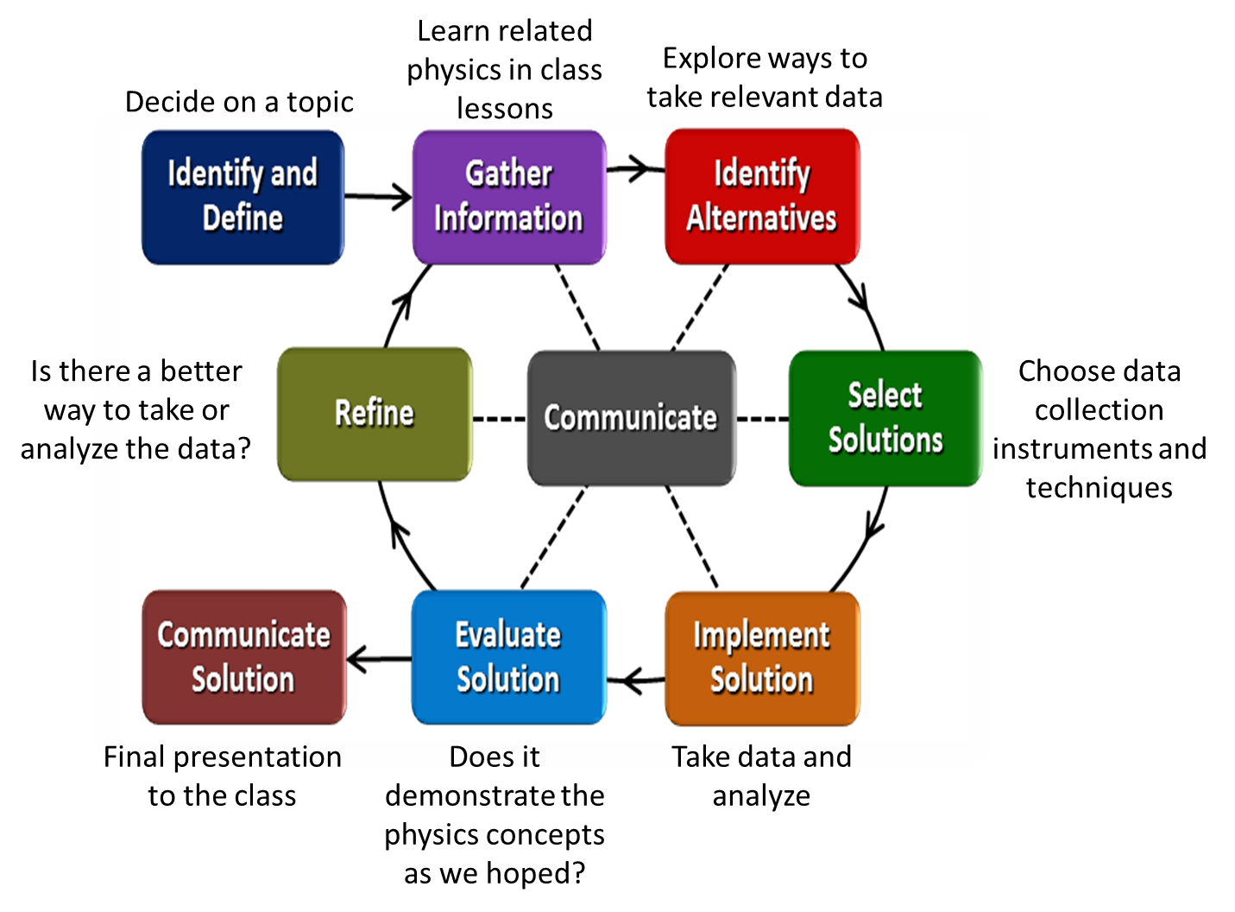Students will choose a concept in physics that they believe relates to the topic that interests them. They will then choose tools and techniques to allow them to take and analyze data and then to present it.
The students will approach their topics using a number of different strategies:
- Think about what’s going on.
- Draw an annotated sketch.
- Look at the event through each of the four lenses and consider which is the most helpful; use the concepts and equations associated with this lens.
- Consider what would happen if the question was slightly different…if the problem was upside down, or if one of the masses were way, way larger than the other.
- Simplify the problem so the behavior will be obvious.
- Imagine a scenario where you have observed something similar.
- Consider whether the answer makes sense.
Finding a formula and putting in numbers can be a part of the process, but it is usually a small part. The italicized strategies should be used with almost every undertaking; the others will be helpful sometimes; and you may have other strategies that you will also want to use.
Our iteration will be making changes to data collection techniques or data analysis that improve the results. This is important for minimizing errors in instrument usage and analysis.
How will students present or defend the solution? Describe if any formal training or resource guides will be provided to the students for best practices (e.g., poster, flyer, video, advertisement, etc.) used to present work.
There will be a final group presentation on PowerPoint or Google Slides. The presentation will include:
- The main topic that is being examined
- Annotated sketches
- The process for choosing the type of data to be collected and how it was collected
- Any iterations to the process of data-taking
- The analysis that was chosen to explain the physics concepts that are involved
- The results of the analysis, presented using graphs.
- The importance of the work to their own lives and the lives of others
- At least 3 careers in which people could benefit from being able to do this type of data collection and analysis

What academic content is being taught through this Challenge?
Kinematics, dynamics, momentum, and energy

Assessment and EDP:
Using the diagram above, identify any places in the EDP where assessments should take place, as it applies to your Challenge. Describe below what kinds of assessment are most appropriate.

What EDP Processes are ideal for conducting an Assessment? (List ones that apply.) | List the type of Assessment (Rubric, Diagram, Checklist, Model, Q/A etc.) Check box to indicate whether it is formative or summative.
Identify & Define  Gather Information  Identify Alternatives  Select Solutions  Implement Solution  Evaluation Solution  Refine Solution  Communicate Solution | Force Concept Inventory ☐ formative ☒ summative  In-class Activities & Homework ☒ formative ☐ summative  Pros & Cons Worksheet ☒ formative ☐ summative  Proposed plan ☒ formative ☐ summative  Data Collection & Analysis ☒ formative ☐ summative  Preliminary presentation / Rubric ☒ formative ☐ summative  Proposed plan ☒ formative ☐ summative  Final presentation / Rubric ☐ formative ☒ summative  Force Concept Inventory ☐ formative ☒ summative
Check below which characteristic(s) of this Challenge will be incorporated in its implementation using EDP. (Check all that apply.)
☒ Has clear constraints that limit the solutions
☒ Will produce more than one possible solution that works
☒ Includes the ability to refine or optimize solutions
☒ Assesses science or math content
☒ Includes Math applications
☒ Involves use of graphs
☒ Requires analysis of data
☒ Includes student led communication of findings

5. ACS (Real world applications; career connections; societal impact):
Place an X on the continuum to indicate where this Challenge belongs in the context of real world applications:
Abstract or Loosely Applies to the Real World | |--------------------------------------|--------------------------------------X-| | Strongly Applies to the Real World

Provide a brief rationale for where you placed the X: This is the focus of the entire unit: applying what we are studying in this course to something the students care about in their own lives.
What activities in this Unit apply to real world context? _All._____________________________________

Place an X on the continuum to indicate where this Challenge belongs in the context of societal impact:
Shows Little or No Societal Impact | |-------------------------------------X----------------------------------------| | Strongly Shows Societal Impact

Provide a brief rationale for where you placed the X: This will strongly depend on the topics chosen by the students.

What activities in this Unit apply to societal impact? _Depending on the topics chosen, all activities can apply to societal impact._________________________________________

Careers: What careers will you introduce (and how) to the students that are related to the Challenge? (Examples: career research assignment, guest speakers, fieldtrips, Skype with a professional, etc.)
This will be done mostly through brainstorming with the students. My students typically come from a wide variety of backgrounds, so will likely be able to come up with various technical and engineering examples, and I will fill in during brainstorming as needed to include various fields in science and engineering, with which I am familiar having worked in industry for many years.

6. Misconceptions:

- Acceleration and velocity are always in the same direction.
- If velocity is zero, so is acceleration.
- Removing centripetal force on an object will make it fly directly away from the axis it was circling.
- If there is no change in speed (magnitude of velocity), there is no change in momentum.
- Acceleration in one direction affects velocity in another direction.
7. Unit Lessons and Activities: (Provide a tentative timeline with a breakdown for Lessons 1 and 2. Provide the Lesson #’s and Activity #’s for when the Challenge Based Learning (CBL) and Engineering Design Process (EDP) are embedded in the unit.)

Lesson 1: Students will choose their topics, make a list of subject matter that we will need to cover, and apply the subject matter to their chosen topics
Activity 1: Survey, brainstorming, forming groups, and listing subject matter (2 days)
Activity 2: Three times, students fill out pages in an engineering notebook with something they have learned in class and how they will relate it to their chosen topic (1 day of class time over the course of 8 weeks)
Lesson 2: Students will collect data, analyze it, and present it to the class
Activity 3: Presentation of data collected during RET activity and what it showed. Then an overview of several different ways that smart phone apps can be used to collect data. Students will decide how to collect the data they need and then collect that data outside of class. (1 day)
Activity 4: Sample activity using air pollution data on a major road and correlating it to the power needed by vehicles to drive that stretch of road. Students will learn to analyze data and present it graphically. (1 day)
Activity 5: Students will make a preliminary group presentation, get peer feedback, refine their data collection, analysis, and presentation, and then make a final presentation two weeks later. (4 days, over the course of 2 weeks)
CBL: Lesson 1, Activity 1
Lesson 2, Activity 3
Lesson 2, Activity 5
EDP: Lesson 1, Activity 1
Lesson 1, Activity 2
Lesson 2, Activity 3
Lesson 2, Activity 5
8. Keywords:

Physics, application, forces, energy, momentum, dynamics, kinematics, college, university

9. Additional Resources:

10. Pre-Unit and Post-Unit Assessment Instruments:

We will use the Force Concept Inventory or Mechanics Baseline Test as pre- and post-test:
https://www.physport.org/assessments/assessment.cfm?I=5&A=FCI
As per the recommendations from PhysPort, students will receive credit for completing the assessment but will not receive a grade based on their performance on the assessment.
11. Poster | 12. Video (Link here.)

If you are a science teacher, check the boxes below that apply:
Next Generation Science Standards (NGSS)
Science and Engineering Practices (Check all that apply) | Crosscutting Concepts (Check all that apply)
☒ Asking questions (for science) and defining problems (for engineering) | ☐ Patterns
☐ Developing and using models | ☐ Cause and effect
☐ Planning and carrying out investigations | ☐ Scale, proportion, and quantity
☒ Analyzing and interpreting data | ☐ Systems and system models
☐ Using mathematics and computational thinking | ☐ Energy and matter: Flows, cycles, and conservation
☒ Constructing explanations (for science) and designing solutions (for engineering) | ☐ Structure and function.
☐ Engaging in argument from evidence | ☐ Stability and change.
☒ Obtaining, evaluating, and communicating information

If you are a science teacher, check the boxes below that apply:
Ohio’s Learning Standards for Science (OLS)
Expectations for Learning - Cognitive Demands (Check all that apply)
☐ Designing Technological/Engineering Solutions Using Science concepts (T)
☐ Demonstrating Science Knowledge (D)
☐ Interpreting and Communicating Science Concepts (C)
☐ Recalling Accurate Science (R)

If you are a math teacher, check the boxes below that apply:
Ohio’s Learning Standards for Math (OLS) or
Common Core State Standards -- Mathematics (CCSS)
Standards for Mathematical Practice (Check all that apply)
☐ Make sense of problems and persevere in solving them | ☐ Use appropriate tools strategically
☐ Reason abstractly and quantitatively | ☐ Attend to precision
☐ Construct viable arguments and critique the reasoning of others | ☐ Look for and make use of structure
☐ Model with mathematics | ☐ Look for and express regularity in repeated reasoning

Part 2: Post Implementation- Reflection on the Unit
Results: Evidence of Growth in Student Learning - After the Unit has been taught and the Post-Unit Assessment Instrument has been used to assess student growth in learning, the teacher must analyze the data and determine whether or not student growth in learning occurred. Present all documents used to collect and organize Post- Unit evaluation data such as graphs or charts. Provide a written analysis in sentence or paragraph form which provides the evidence that student growth in learning took place. Please present results and, if applicable, student work (as a hyperlink) used as evidence after the Unit has been taught.

Please include:
- Any documents used to collect and organize post unit evaluation data. (charts, graphs and /or tables etc.)
- An analysis of data used to measure growth in student learning providing evidence that student learning occurred. (Sentence or paragraph form.)
- Other forms of assessment that demonstrate evidence of learning.
- Anecdotal information from student feedback.

Reflection: Reflections: Reflect upon the successes of teaching in this Unit in 5 or more sentences in the form of a narrative. Consider the following questions:
- Why did you select this content for the Unit?
- Was the purpose for selecting the Unit met? If yes, provide student learning related evidence. If not, provide possible reasons.
- Did the students find a solution or solutions that resulted in concrete meaningful action for the Unit’s Challenge? Hyperlink examples of student solutions as evidence.
- What does the data indicate about growth in student learning?
- What would you change if you re-taught this Unit?
- Would you teach this Unit again? Why or why not?

Name: Dean Stocker | Contact Info: dean.stocker@uc.edu | Date: 2018-07-09
Lesson Title : Connecting physics to our lives | Unit #: 1 | Lesson #:  1 | Activity #:  1
Activity Title: Making Connections with Physics

Estimated Lesson Duration: | 3 days of class time, over the course of 9 weeks
Estimated Activity Duration: | 2 days, in the first 2 weeks

Setting: | College classroom

Activity Objectives:
Students will be able to:
- Identify various aspects of their lives (job, home, sports/hobbies, the environment, or transportation) that may relate to physics.
- Choose a topic to investigate from among the relationships they have identified between their lives and physics.
- Construct guiding questions about how physics relates to their chosen topics.
Activity Guiding Questions:
- How does physics relate to my job / my home / the sports I enjoy / my hobbies / the environment / transportation?
- What topic would I like to learn more about, related to physics and my own life?
- We will be studying kinematics, dynamics, momentum, and energy. Which of these are related to the topic I have chosen?
Next Generation Science Standards (NGSS)
Science and Engineering Practices (Check all that apply) | Crosscutting Concepts (Check all that apply)
☒ Asking questions (for science) and defining problems (for engineering) | ☐ Patterns
☐ Developing and using models | ☐ Cause and effect
☐ Planning and carrying out investigations | ☐ Scale, proportion, and quantity
☐ Analyzing and interpreting data | ☐ Systems and system models
☐ Using mathematics and computational thinking | ☐ Energy and matter: Flows, cycles, and conservation
☐ Constructing explanations (for science) and designing solutions (for engineering) | ☐ Structure and function.
☐ Engaging in argument from evidence | ☐ Stability and change.
☐ Obtaining, evaluating, and communicating information

Ohio’s Learning Standards for Science (OLS)
Expectations for Learning - Cognitive Demands (Check all that apply)
☐ Designing Technological/Engineering Solutions Using Science concepts (T)
☐ Demonstrating Science Knowledge (D)
☐ Interpreting and Communicating Science Concepts (C)
☐ Recalling Accurate Science (R)

Ohio’s Learning Standards for Math (OLS) and/or
Common Core State Standards -- Mathematics (CCSS)
Standards for Mathematical Practice (Check all that apply)
☐ Make sense of problems and persevere in solving them | ☐ Use appropriate tools strategically
☐ Reason abstractly and quantitatively | ☐ Attend to precision
☐ Construct viable arguments and critique the reasoning of others | ☐ Look for and make use of structure
☐ Model with mathematics | ☐ Look for and express regularity in repeated reasoning

Unit Academic Standards (NGSS, OLS and/or CCSS):

Materials: (Link Handouts, Power Points, Resources, Websites, Supplies)
- Pre-class survey (1.1.1a)
- PowerPoint with student ideas and associated images (1.1.1b)
- Whiteboards and whiteboard markers (1 board for every 2 students)
- 3x5 notecards
- Rubric for final project (1.2.5g)
Teacher Advance Preparation:
- Have students complete a pre-class survey with questions about the ways physics impacts their lives.
- Prepare PowerPoint presentation with survey results and corresponding images. Start the continuously scrolling slideshow before students enter.
Activity Procedures:
Day 1: Students complete pre-class survey (see 1.1.1a for relevant questions).
NOTE: Answers are not discussed with students, but put into a PowerPoint slideshow with relevant images in preparation for Day 2 (see 1.1.1b as an example).
Day 2: NOTE: This is at least one week after “Day 1,” after students have been introduced to the basic physics concepts that will be covered over the course of the term.
- Students watch slideshow as they are settling into class (watching for their own comments to appear).
- Students work in pairs with whiteboards, brainstorming ideas of ways that physics relates to their everyday lives in any or all of the following areas: job, home, sports, hobbies, the environment, and/or transportation.
- Pairs of students circle one or two of the topics on their whiteboards that they would most like to study.
- Students place whiteboards on the blackboard rail so the whole class can see the things that are written.
- Students choose from the circled items, writing their top 3 choices for the topics they would most like to learn.
- Students form groups of 3-4 with others who have a common topic written on their card. These will be the groups and their topics for the final class project. If the students are unable to form appropriate groups, the teacher will change groups as needed.
- Groups develop a list of 3-4 guiding questions that they would like me to address in class in order for them to be able to understand the physics related to their chosen topic. The questions should be specific: Not “How is momentum related to archery” but “How can we determine the momentum given to an arrow when it is fired from a bow?” This list is submitted electronically to the teacher through the online Learning Management System.
- Group members decide together who will take on various roles in the group. The roles indicate the person who is responsible for making sure the group performs well in certain areas. The role does NOT indicate that the person is responsible for doing the work themselves. The roles are: Artist, Coach, Engineer, and Manager. If there are only three group members then the Manager role will not exist for that group. Students should have the final rubric available to them, because in the final presentation the person in each role will have the possibility of earning an extra point for each 4/4 their team gets in the role’s three areas of responsibility.
Formative Assessments: Link the items in the Activities that will be used as formative assessments.

Pre-class survey (credit for completion only), walking around to different groups during the activity, guiding questions submitted electronically (rubric 1.0.0d).
Summative Assessments: These are optional; there may be summative assessments at the end of a set of Activities or only at the end of the entire Unit.

The summative assessment will be the final presentation at the end of the unit.
Differentiation: Describe how you modified parts of the Lesson to support the needs of different learners.
Refer to Activity Template for details.

Reflection: Reflect upon the successes and shortcomings of the lesson.

Name: Dean Stocker | Contact Info: dean.stocker@uc.edu | Date: 2018-07-13

Lesson Title : Connecting physics to our lives | Unit #: 1 | Lesson #:  1 | Activity #:  2
Activity Title: Making Connections with Physics

Estimated Lesson Duration: | 3 days of class time, over the course of 9 weeks
Estimated Activity Duration: | 1 day

Setting: | College classroom

Activity Objectives:
Students will be able to:
- Identify course content that is relevant to their chosen topic of study.
- Apply course content to their chosen topic.
- Keep records of relevant course content in an engineering notebook, complete with annotated figures and witness signatures.
Activity Guiding Questions:
- Can I relate today’s lesson to my chosen topic?
- What notes do I need to take in order to remember what I learned today and relate it to my chosen topic?
- Can I go beyond what I learned today and actually apply it to my chosen topic?
- Can I understand what my other team members have written in their engineering notebooks?
Next Generation Science Standards (NGSS)
Science and Engineering Practices (Check all that apply) | Crosscutting Concepts (Check all that apply)
☐ Asking questions (for science) and defining problems (for engineering) | ☐ Patterns
☐ Developing and using models | ☐ Cause and effect
☒ Planning and carrying out investigations | ☐ Scale, proportion, and quantity
☐ Analyzing and interpreting data | ☐ Systems and system models
☐ Using mathematics and computational thinking | ☐ Energy and matter: Flows, cycles, and conservation
☒ Constructing explanations (for science) and designing solutions (for engineering) | ☐ Structure and function.
☐ Engaging in argument from evidence | ☐ Stability and change.
☒ Obtaining, evaluating, and communicating information

Ohio’s Learning Standards for Science (OLS)
Expectations for Learning - Cognitive Demands (Check all that apply)
☐ Designing Technological/Engineering Solutions Using Science concepts (T)
☐ Demonstrating Science Knowledge (D)
☐ Interpreting and Communicating Science Concepts (C)
☐ Recalling Accurate Science (R)

Ohio’s Learning Standards for Math (OLS) and/or
Common Core State Standards -- Mathematics (CCSS)
Standards for Mathematical Practice (Check all that apply)
☐ Make sense of problems and persevere in solving them | ☐ Use appropriate tools strategically
☐ Reason abstractly and quantitatively | ☐ Attend to precision
☐ Construct viable arguments and critique the reasoning of others | ☐ Look for and make use of structure
☐ Model with mathematics | ☐ Look for and express regularity in repeated reasoning

Unit Academic Standards (NGSS, OLS and/or CCSS):

Materials: (Link Handouts, Power Points, Resources, Websites, Supplies)
- Engineering notebooks. I am using regular quadrille notebooks with a stamp (1.1.2c) across the bottom.

Teacher Advance Preparation:
- Have engineering notebooks ready, or notebooks and a stamp for students to use to make their own.
- Have a place to store engineering notebooks in the classroom, so students can’t take them home and forget to bring them to class.
- Have one page of an engineering notebook filled out as an example—this could be an online resource.

Activity Procedures:
- Show a completed page of an engineering notebook on the screen, and point out the components and reasons for having such a notebook.
- Give students a sample problem to solve in their engineering notebooks (for example, you are going to open a pizzeria, selling pizzas that everyone will want to come and buy because there is no place else in the world that has pizzas like this; design this unusual pizza that will bring in the customers). Students have to sign their own pages, witness another student’s page, and submit the notebook for evaluation.
- For the next 8 weeks, students will collect their notebooks at the beginning of class and return them at the end. They will record information relevant to their chosen topic in the notebooks, including things presented in class and their own thoughts of how to use the material. The notebooks must be witnessed by another team member after they have understood the material.
- A minimum of three times over the eight weeks the students will notify the instructor that they have a record to be graded, and the date of the record. These entries will be graded according to the rubric in 1.0.0d. Each student will be allowed to have four entries graded, in which case the lowest score will be dropped.
- Once over the next eight weeks, each student will be approached by the instructor and asked to explain a page that they have witnessed in another student’s engineering notebook, and this explanation will also be graded as a part of the rubric 1.0.0d.
Formative Assessments: Link the items in the Activities that will be used as formative assessments.

Entries in engineering notebooks
Summative Assessments: These are optional; there may be summative assessments at the end of a set of Activities or only at the end of the entire Unit.

The summative assessment will be the final presentation at the end of the unit.
Differentiation: Describe how you modified parts of the Lesson to support the needs of different learners.
Refer to Activity Template for details.

Reflection: Reflect upon the successes and shortcomings of the lesson.

Name: Dean Stocker | Contact Info: dean.stocker@uc.edu | Date: 2018-07-14

Lesson Title : Collecting, Analyzing, and Presenting Data | Unit #: 1 | Lesson #:  2 | Activity #:  3
Activity Title: Collecting Data

Estimated Lesson Duration: | 6 days of class time, over the course of 3 weeks
Estimated Activity Duration: | 1 day

Setting: | College classroom

Activity Objectives:
Students will be able to:
- Use their smartphones to collect data.
- Create a plan to take data related to their chosen topic.
Activity Guiding Questions:
- What apps are available for my smartphone that could be useful for taking data on my chosen topic?
- What kind of data should we take for my chosen topic?
Next Generation Science Standards (NGSS)
Science and Engineering Practices (Check all that apply) | Crosscutting Concepts (Check all that apply)
☒ Asking questions (for science) and defining problems (for engineering) | ☐ Patterns
☐ Developing and using models | ☐ Cause and effect
☒ Planning and carrying out investigations | ☐ Scale, proportion, and quantity
☐ Analyzing and interpreting data | ☐ Systems and system models
☐ Using mathematics and computational thinking | ☐ Energy and matter: Flows, cycles, and conservation
☐ Constructing explanations (for science) and designing solutions (for engineering) | ☐ Structure and function.
☐ Engaging in argument from evidence | ☐ Stability and change.
☒ Obtaining, evaluating, and communicating information

Ohio’s Learning Standards for Science (OLS)
Expectations for Learning - Cognitive Demands (Check all that apply)
☐ Designing Technological/Engineering Solutions Using Science concepts (T)
☐ Demonstrating Science Knowledge (D)
☐ Interpreting and Communicating Science Concepts (C)
☐ Recalling Accurate Science (R)

Ohio’s Learning Standards for Math (OLS) and/or
Common Core State Standards -- Mathematics (CCSS)
Standards for Mathematical Practice (Check all that apply)
☐ Make sense of problems and persevere in solving them | ☐ Use appropriate tools strategically
☐ Reason abstractly and quantitatively | ☐ Attend to precision
☐ Construct viable arguments and critique the reasoning of others | ☐ Look for and make use of structure
☐ Model with mathematics | ☐ Look for and express regularity in repeated reasoning

Unit Academic Standards (NGSS, OLS and/or CCSS):

Materials: (Link Handouts, Power Points, Resources, Websites, Supplies)
- Worksheet 1.2.3e “Smartphone physics apps”
- Accelerometer, etc. for iPhone (search for Lab4Physics in app store)
https://itunes.apple.com/us/app/lab4physics/id1049405068?mt=8
- Accelerometer, etc. for Android (search for Lab4Physics in Google Play store) https://play.google.com/store/apps/details?id=com.lab4u.lab4physics&hl=en_US
- GPS logger for Android (search for GPS Logger in Google Play store)
https://play.google.com/store/apps/details?id=eu.basicairdata.graziano.gpslogger&hl=en_US
- GPS logger for iPhone (search for “myTracks - The GPS-Logger” in app store)
https://itunes.apple.com/us/app/mytracks-the-gps-logger/id358697908?mt=8
- Putting GPS data into Google Maps: http://maps.google.com, “Your places” in menu on left, “MAPS” tab, “CREATE MAP” at bottom, import from CSV.
- Shooting slow-motion video with iPhone
http://www.idownloadblog.com/2017/11/22/how-to-shoot-slo-mo-video-1080p-at-240fps-iphone/
- Software for tracking objects on video, and using this to determine velocity, acceleration, etc. (from this website you can download the software for Windows, Mac, or Linux)
https://physlets.org/tracker/

Teacher Advance Preparation:
- PowerPoint presentation of research that was previously done.
- Notify students that for this class they will need to bring their smartphones with plenty of charge.
Activity Procedures:
- Give a presentation that incorporates data taken using a smartphone.
- Give students the links above for various apps and software, and have them complete the activities on Worksheet 1.2.3e.
- I will monitor the groups’ activities as they complete the worksheet. They will likely not finish during class time, so will be allowed to finish the worksheet as homework to be turned in at the beginning of the next session.
- Homework: The students, as a team, will decide upon the data that should be taken to support their final project and submit a plan for collecting the data for approval.
- After they receive approval, the team will collect the needed data.
Formative Assessments: Link the items in the Activities that will be used as formative assessments.

Monitoring as they start the worksheet in class, the completed worksheets 1.2.3e, and the data collection plan
Summative Assessments: These are optional; there may be summative assessments at the end of a set of Activities or only at the end of the entire Unit.

The summative assessment will be the final presentation at the end of the unit.
Differentiation: Describe how you modified parts of the Lesson to support the needs of different learners.
Refer to Activity Template for details.

Reflection: Reflect upon the successes and shortcomings of the lesson.

Name: Dean Stocker | Contact Info: dean.stocker@uc.edu | Date: 2018-07-15

Lesson Title : Collecting, Analyzing, and Presenting Data | Unit #: 1 | Lesson #:  2 | Activity #:  4
Activity Title: Analyzing Data

Estimated Lesson Duration: | 6 days of class time, over the course of 3 weeks
Estimated Activity Duration: | 1 day (or 2 days with optional portion included)

Setting: | College classroom

Activity Objectives:
Students will be able to:
- Observe relationships in collected data.
- Create graphs and/or charts to show relationships in collected data.
- Use sentences to describe the relationships shown in graphs and charts.
Activity Guiding Questions:
- What do I see happening in the data?
- How can I represent the data in a graph or chart so that it can be easily understood?
- How can I clearly describe what is shown in a graph or chart?
Next Generation Science Standards (NGSS)
Science and Engineering Practices (Check all that apply) | Crosscutting Concepts (Check all that apply)
☒ Asking questions (for science) and defining problems (for engineering) | ☐ Patterns
☐ Developing and using models | ☐ Cause and effect
☐ Planning and carrying out investigations | ☐ Scale, proportion, and quantity
☒ Analyzing and interpreting data | ☐ Systems and system models
☒ Using mathematics and computational thinking | ☐ Energy and matter: Flows, cycles, and conservation
☐ Constructing explanations (for science) and designing solutions (for engineering) | ☐ Structure and function.
☒ Engaging in argument from evidence | ☐ Stability and change.
☐ Obtaining, evaluating, and communicating information

Ohio’s Learning Standards for Science (OLS)
Expectations for Learning - Cognitive Demands (Check all that apply)
☐ Designing Technological/Engineering Solutions Using Science concepts (T)
☐ Demonstrating Science Knowledge (D)
☐ Interpreting and Communicating Science Concepts (C)
☐ Recalling Accurate Science (R)

Ohio’s Learning Standards for Math (OLS) and/or
Common Core State Standards -- Mathematics (CCSS)
Standards for Mathematical Practice (Check all that apply)
☐ Make sense of problems and persevere in solving them | ☐ Use appropriate tools strategically
☐ Reason abstractly and quantitatively | ☐ Attend to precision
☐ Construct viable arguments and critique the reasoning of others | ☐ Look for and make use of structure
☐ Model with mathematics | ☐ Look for and express regularity in repeated reasoning

Unit Academic Standards (NGSS, OLS and/or CCSS):

Materials: (Link Handouts, Power Points, Resources, Websites, Supplies)
- Whiteboards
- Large post-it notes
- Air pollution data collected along a major roadway, generally showing larger concentrations of pollution in stretches of road that have steeper grades.
Teacher Advance Preparation:
- Prepare several sets of data, at least one of which can be represented well in a scatter plot, one in a bar graph, and one in a pie chart. (see 1.2.4f)

Activity Procedures:
- Give samples of various ways that data can be presented, and a quick overview of how Excel can be used to make various types of graphs.
- Divide the class into several groups. Present the data in 1.2.4f and have student groups attempt to make scatter plots, bar charts, and pie charts from each set of data.
- After they have attempted all three types of chart for the first data set, the groups choose which chart is the best way to represent the data, and make a version of this chart that can be posted on a wall. If the resources are available, the charts can be made in Excel and printed out. If not, they should be done on whiteboards. If the plots are to be done by hand, state that for pie charts the wedges should just be approximate, not measured.
- Gallery walk. For each data set, every student chooses the chart that they believe is the best from among the charts the OTHER groups made, writes what makes it the best, and puts the post-it on the chart (along with the student’s name). I will photograph each chart along with the post-it notes.
- Repeat steps 3 & 4 for the second set of data.
- Optional: A second day can be used to analyze road pollution data. This will require students to decide physically what is going on to make high pollution on the sloped areas of the road, then decide on the relevant physical parameters, estimate the values of the relevant parameters, determine the independent and dependent variables, decide on what type of chart will make the best representation, and create the chart along with an explanation for what is observed. I will likely not do this because it is quite complex and I am afraid it will use too much class time.
Formative Assessments: Link the items in the Activities that will be used as formative assessments.

Monitoring as they work on the charts, assessing the quality of the charts and the feedback students give each other with the post-it notes.
Summative Assessments: These are optional; there may be summative assessments at the end of a set of Activities or only at the end of the entire Unit.

The summative assessment will be the final presentation at the end of the unit.
Differentiation: Describe how you modified parts of the Lesson to support the needs of different learners.
Refer to Activity Template for details.

Reflection: Reflect upon the successes and shortcomings of the lesson.

Name: Dean Stocker | Contact Info: dean.stocker@uc.edu | Date: 2018-07-15

Lesson Title : Collecting, Analyzing, and Presenting Data | Unit #: 1 | Lesson #:  2 | Activity #:  5
Activity Title: Presenting Data

Estimated Lesson Duration: | 6 days of class time, over the course of 3 weeks
Estimated Activity Duration: | 4 days

Setting: | College classroom

Activity Objectives:
Students will be able to:
- Present data clearly using PowerPoint or Google Slides:
  - Describe the physics of their chosen topic accurately
  - Explain data collection techniques.
  - Provide appropriate graphical representations of their data.
- Critique the work of their peers using the rubric for the final presentation (1.2.5g).

Activity Guiding Questions:
- How can we best communicate the information we have learned about our chosen topic?

Next Generation Science Standards (NGSS)
Science and Engineering Practices (Check all that apply) | Crosscutting Concepts (Check all that apply)
☐ Asking questions (for science) and defining problems (for engineering) | ☐ Patterns
☐ Developing and using models | ☐ Cause and effect
☐ Planning and carrying out investigations | ☐ Scale, proportion, and quantity
☐ Analyzing and interpreting data | ☐ Systems and system models
☐ Using mathematics and computational thinking | ☐ Energy and matter: Flows, cycles, and conservation
☒ Constructing explanations (for science) and designing solutions (for engineering) | ☐ Structure and function.
☒ Engaging in argument from evidence | ☐ Stability and change.
☒ Obtaining, evaluating, and communicating information

Ohio’s Learning Standards for Science (OLS)
Expectations for Learning - Cognitive Demands (Check all that apply)
☐ Designing Technological/Engineering Solutions Using Science concepts (T)
☐ Demonstrating Science Knowledge (D)
☐ Interpreting and Communicating Science Concepts (C)
☐ Recalling Accurate Science (R)

Ohio’s Learning Standards for Math (OLS) and/or
Common Core State Standards -- Mathematics (CCSS)
Standards for Mathematical Practice (Check all that apply)
☐ Make sense of problems and persevere in solving them | ☐ Use appropriate tools strategically
☐ Reason abstractly and quantitatively | ☐ Attend to precision
☐ Construct viable arguments and critique the reasoning of others | ☐ Look for and make use of structure
☐ Model with mathematics | ☐ Look for and express regularity in repeated reasoning

Unit Academic Standards (NGSS, OLS and/or CCSS):

Materials: (Link Handouts, Power Points, Resources, Websites, Supplies)
- Presentation rubrics to hand out. My version 1.2.5g is based on the one by msedaghatian1 on slideshare.net, https://www.slideshare.net/msedaghatian1/power-point-presentation-rubric-4088342
- Video recorder

Teacher Advance Preparation:
- Make sure that all teams have a way to present their work on a projector screen: sharing files with the instructor, bringing their own laptops to connect, etc.
- Set up video recorder on tripod.

Activity Procedures:
- Students are given at least two weeks to collect and analyze data and put it into a slide presentation. Some class time (1 day per week) is allotted for this, and the rest must be done outside of class.
- On the first presentation day, pass out rubrics for peers to use in evaluating each other. There may be a way to do this electronically if students are able to use devices in class without being overly distracted! I will do it with handouts for the first time through.
- Groups make their presentations to the class (10-15 minutes), their classmates fill out their assessments, and 5 minutes of questions and feedback is allowed while the next group gets ready. Video of the presentation should be recorded and provided to the students so they can watch their own presentation.
- The groups will get all of the forms with feedback from their peers and will have 2 weeks to refine their presentation (possibly retaking some data) before giving their final presentation in the last two days of the class. Students will peer review each other with the rubric 1.2.5g and instructor will also use the same rubric. The final presentation will be recorded using video to make grading easier to do after the fact.
Formative Assessments: Link the items in the Activities that will be used as formative assessments.

Working with groups over the two weeks as they take data and get ready for the first presentation. Feedback on the first presentation. Working with groups over the two weeks as they refine their presentations.
Summative Assessments: These are optional; there may be summative assessments at the end of a set of Activities or only at the end of the entire Unit.

The summative assessment is the final presentation at the end of this activity.
Differentiation: Describe how you modified parts of the Lesson to support the needs of different learners.
Refer to Activity Template for details.

Reflection: Reflect upon the successes and shortcomings of the lesson.

- APPENDIX IV: UNIT PLAN FOR MARIE POLLITT

Name: Marie Pollitt |  | Contact Info: pollittmarie@gmail.com |  | Date: 6-20-18
Unit Number and Title: Environmental Remediation
Grade Level: | 8
Subject Area: | Science
Total Estimated Duration of Entire Unit: |  |  | 13 days (70 minute classes)

Part 1: Designing the Unit
- Unit Academic Standards (Identify which standards: NGSS, OLS and/or CCSS. Cut and paste from NGSS, OLS and/or CCSS and be sure to include letter and/or number identifiers.):
Topic: Species and Reproduction
Standard: This topic focuses on continuation of the species.
Content Statements:
- 8.LS.1: Diversity of species occurs through gradual processes over many generations. Fossil records provide evidence that changes have occurred in number and types of species.
- 8.LS.2: Reproduction is necessary for the continuation of every species.

- Unit Summary
The Big Idea (including global relevance):
Pollution and the Environment
Pollution negatively affects humans, animals, plants, and ecosystems. There are many causes of environmental pollution such as industry, transportation, agriculture activity, trading activity, and residences. Although there are many environmental regulations, toxins are released into the environment at an abundant rate; for example, the W.C. Beckjord Station and its 10 billion pounds of coal ash ponds. These unlined ponds are located along the banks of the Ohio River and contain arsenic, mercury, sulfuric acid, lead, and many other toxins.

The (anticipated) Essential Questions: List 3 or more questions your students are likely to generate on their own. (Highlight in yellow the one selected to define the Challenge):
- How can we safely remove the toxins?
- How can we clean up the toxins at the power plant?
- How can we clean up the environment at Beckjord?
- How can toxins be removed from an area without causing more harm?
- How can we safely clean up pollutants?
- How can we safely clean up pollutants at a power plant?
- How can the Ohio River bank be free of toxic chemicals left behind from the power plant?
- How can we clean up toxins from the Ohio River bank left behind by the power plant?

- Unit Context
Justification for Selection of Content– Check all that apply:
☐ Students previously scored poorly on standardized tests, end-of term test or any other test given in the school or district on this content.
☐ Misconceptions regarding this content are prevalent.
☐ Content is suited well for teaching via CBL and EDP pedagogies.
☐ The selected content follows the pacing guide for when this content is scheduled to be taught during the school year. (Unit 1 covers atomic structure because it is taught in October when I should be conducting my first unit.)
☐ Other reason(s) __________________________________________________________

The Hook: (Describe in a few sentences how you will use a “hook” to introduce the Big Idea in a compelling way that draws students into the topic.)
- Students are taking a field trip to a floating classroom where they will participate in two hands-on learning activities. They will learn about the value of clean water, waste reduction, and recycling.
  - Field Trip Workshop (Living Lands & Waters): Biological Magnification & Eyes on Invasions
- The day after the field trip, students will watch Big Decisions Loom for Toxic Ponds on Ohio River and then be introduced to the Big Idea (Pollution and the Environment).

The Challenge and Constraints:
☐ Product or ☐ Process (Check one)
Description of Challenge (Either Product or Process is clearly explained below): | List the Constraints Applied
Students will design a plan to safely clean up the ash ponds at Beckjord. | Must use a living organism to aid in the process.  - Provide a safety plan for proper disposal of the organism they introduced to the environment.  - Match an organism with known qualities for improving the environment with the specific toxin needing removal. (Justify this.)  Refine:  - Your team is unable to use the current organism for the clean-up due to a shortage. The team will need to find an alternative solution to complete the job.  - The new organism must clean-up the same toxins.

Teacher’s Anticipated Guiding Questions (that apply to the Challenge and may change with student input.):
- What kind of pollutants were left behind from operating the power plant?
- How do they study the effects in the environment?
- How has the pollution impacted the environment?
- How has the pollution changed organisms in the environment?
- How do you clean-up the pollutants?
- Is there a safe way to clean up the power plant?
- What happens with the materials (new organism) after it has clean up the area?

4. EDP: Use the diagram below to help you complete this section.
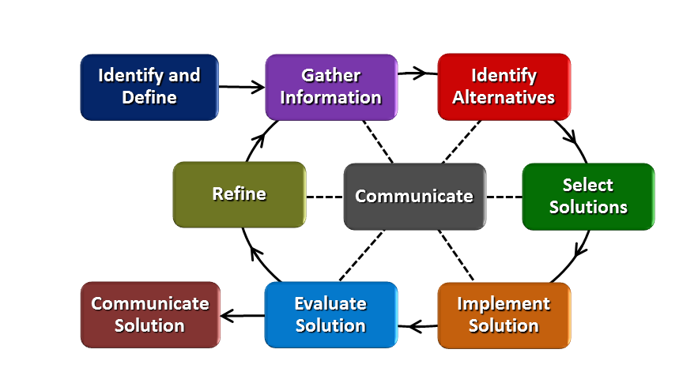
How will students test or implement the solution? What is the evidence that the solution worked? Describe how the iterative process from the EDP applies to your Challenge.
- Identify & Define the Problem section on the graphic organizer.
  - Students developed the essential question and challenge in the beginning of the unit.
  - Students will help develop the criteria, constraints, and available materials list.
  - Gather Information
    - Students will research if there are any existing ideas that can help you in your plan such as toxins in ash ponds. Is there any information you learned during the investigations that may help you solve the challenge? Identify any questions you still need to find answers to that may help you solve the challenge.
      - Students will research the different types of pollutants at a specific power plant (Beckjord). They will devise a plan that will use a living organism to remove one of the pollutants from the ash ponds.
  - Identify Alternatives
    - Use the information gathered during the investigations and research to brainstorm possible solutions. List, describe, and/ or sketch and label at least four plans for your process. When developing your solutions, keep in mind the criteria and constraints. You may use additional paper if needed.
    - Use the team’s plan to develop the process by doing the necessary research to solve the challenge.
  - Select Solution
    - Team members will take turns sharing their ideas for the plan. Together as a team, decide on three possible processes to consider further. After all three processes are developed, complete the Pros and Cons section.
  - Implement Solution
    - As a team, choose one particular process to research further. Provide an explanation (claims, evidence and reasoning) of why you choose this particular process. Be sure to include what type of resources your team will use, how the team will document your sources, roles for each team member.
  - Evaluate
    - This is where you will support the team’s process. Provide an overview of the organism being used, its reproductive process, positive and negative ramifications of introducing the species to the environment, as well as identify any mutations that may occur. Provide a safety plan for proper disposal of the organism introduced to the environment.
      - In order to be successful, the organism(s) chosen to clean may or may not have variation in the species. It will depend on the pros and cons of the introduction of the species; for example, if it will be invasive to the environment.
      - They have to justify if the practice of using the organism is an environmentally safe practice.
          - Provide the positives and negatives of introducing the new organism to the surrounding environment.
          - Identify typical mutations that occur in the species.
      - Provide a safety plan for proper disposal of the organism they introduced to the environment.
          - May have to introduce another organism. The organism may or may not have diversity in the species.
          - May use chemical or physical changes to safely remove the organism from the environment.
  - Refine
    - After all students have presented and received feedback. Introduce the refine portion of the EDP. The teams will be given the following situation:
      - Your company is unable to use the current organism for clean up due to a shortage. The company will need to provide an alternative solution to complete the job.
          - The new organism being used must clean-up the same toxins as the previous organism.
          - Be sure to provide the same information that was required before.
          - Add additional slides to the presentation.
          - Present again and include the new information as well as any feedback received from your peers.

How will students present or defend the solution? Describe if any formal training or resource guides will be provided to the students for best practices (e.g., poster, flyer, video, advertisement, etc.) used to present work.
- Communicate Solution (Part 1: Reflection)
  - EDP Graphic Organizer
    - Communicate Solution: What changes could you make to your design next time? What successes did you have during your challenge? What were some challenges you faced and how did you address them.
- Communicate Solution (Part 2: Presentation)
  - Group Presentation
    - Students will create a sales pitch to the EPA discussing how their solution will help clean up the aftermath of the power plant. They will need to incorporate Google Slides or PPT during the pitch.
    - The Google Slides or PPT should include the following components:
      - Company Name and Employees’ Names
        - Pollutant they are removing;
        - Research collected that supports using the organism that will remove the pollutant with appropriate citation;
        - Organism being introduced to the environment;
        - Overview of the organism being introduced;
        - Organism’s reproductive process;
        - Positive and negatives ramifications of introducing the organism to the environment;
        - Possible mutations that could occur;
        - Detailed safety plan for proper disposal of the organism they introduced to the environment.
        - Careers in Environmental Remediation
          - Include a description, salary (range and median), and training/education needed.
- Students will deliver a presentation to the class.
- As groups are presenting, have students provide feedback using 1.2.5b Slide Presentation Rubric for each group.
  - All students will provide feedback. It may be easier if each team assigns sections to each team member.
    - Eliminate enough copies of the rubric for a class set.
    - With the eliminated rubric and a dry erase marker, students can complete their portion of the rubric for the team presenting.
    - Once the group is finished presenting, the teams can transfer their section onto the printed rubric.
    - Each team should receive one completed rubric per team in the class.

What academic content is being taught through this Challenge?
- Changes in environmental conditions can affect how beneficial a trait will be for the survival and reproductive success of an organism or an entire species.
- Throughout Earth’s history, extinction of a species has occurred when the environment changes and the individual organisms of that species do not have the traits necessary to survive and reproduce in the changed environment. Most species (approximately 99 percent) that have lived on Earth are now extinct.
- Every organism alive today comes from a long line of ancestors who reproduced successfully every generation. Reproduction is the transfer of genetic information from one generation to the next. It can occur with mixing of genes from two individuals (sexual reproduction). It can occur with the transfer of genes from one individual to the next generation (asexual reproduction). The ability to reproduce defines living things.

Assessment and EDP:
Using the diagram above, identify any places in the EDP where assessments should take place, as it applies to your Challenge. Describe below what kinds of assessment are most appropriate.

What EDP Processes are ideal for conducting an Assessment? (List ones that apply.) | List the type of Assessment (Rubric, Diagram, Checklist, Model, Q/A etc.) Check box to indicate whether it is formative or summative.
Identify/Define  Gather Information  Identify Alternatives  Select Solutions  Implement Solutions  Evaluate Solutions  Refine  Communicate Solution (Part 1&2) | CBL Graphic Organizer ☐ formative ☐ summative  Student Lab Sheet ☐ formative ☐ summative  EDP Graphic Organizer ☐ formative ☐ summative  EDP Rubric ☐ formative ☐ summative  Group Presentations/Rubric ☐ formative ☐ summative  Pre/Post Assessment ☐ formative ☐ summative
Check below which characteristic(s) of this Challenge will be incorporated in its implementation using EDP. (Check all that apply.)
☐ Has clear constraints that limit the solutions
☐ Will produce than one possible solution that works
☐ Includes the ability to refine or optimize solutions
☐ Assesses science or math content
☐ Includes Math applications
☐ Involves use of graphs
☐ Requires analysis of data
☐ Includes student led communication of findings

5. ACS (Real world applications; career connections; societal impact):
Place an X on the continuum to indicate where this Challenge belongs in the context of real world applications:
Abstract or Loosely Applies to the Real World | |--------------------------------------|---------------------------------------X| | Strongly Applies to the Real World
Provide a brief rationale for where you placed the X:
- Students collect, analyze, and graphical represent pollution (PM2.5 and Ozone) provided by the Air Quality Agency Ambient Air Monitoring Site in Batavia, Ohio.
- Students learn that organisms are being used to clean up environmental messes such as oil spills, waste water treatment, coal-burning power plants, etc. It is important to understand how the organisms reproduce (sexually or asexually) as well as the advantages and disadvantages of each type of reproduction.

What activities in this Unit apply to real world context?
- Activity 2: Investigating Pollution
- Activity 4: Investigating Reproductive Strategies

Place an X on the continuum to indicate where this Challenge belongs in the context of societal impact:
Shows Little or No Societal Impact | |-------------------------------------|----------------------------------------X| | Strongly Shows Societal Impact
Provide a brief rationale for where you placed the X:

- Pollution impacts many species in the food web especially birds. When a species has continuous exposure to pollutants, it will bioaccumulate in an organism over time; for example, its tissues. This leads to biological magnification.

What activities in this Unit apply to societal impact?
- Activity 1: Challenge Based Learning
  - Hook: Biological Magnification & Eyes on Invasions (Field Trip Workshop)

Careers: What careers will you introduce (and how) to the students that are related to the Challenge? (Examples: career research assignment, guest speakers, field trips, Skype with a professional, etc.)
- An extensive list of careers in environmental remediation can be found at https://www.bls.gov/green/environmental_remediation/remediation.htm
- During the Communicate Solution (Part 2), students create a PowerPoint to present or defend their solution. Students are required to include careers in environmental remediation. They will research one field from the list below and provide specifics for the careers in that area. A bulletin board will be created to display each of the careers as well as the training needed, salary, etc.
  - scientists
    - biochemists & biophysicists
  - chemists
  - chemical technicians
  - conservations scientists
  - environmental scientists & specialists
  - hydrologists
  - microbiologists
- management & business specialists
  - compliance officers
  - construction managers
  - cost estimators
  - emergency management directors
  - natural sciences managers
  - public relations
- engineering & mapping occupations
  - cartographers & photogrammetrists
  - chemical engineers
  - environmental engineers
  - environmental engineering technicians
  - health and safety engineers
  - mining and geological engineers
- construction & material- moving occupations
  - construction laborers
  - dredge operators
  - earth drillers
  - excavating and loading machines and dragline operators
  - hazardous materials removal workers
  - operating engineers and other construction operators

6. Misconceptions:
- Evolution of Life, states many students believe that environmental conditions are responsible for changes in traits or that organisms develop new traits because they need them to survive.
- Heredity, highlights that students think sexual reproduction results in traits being inherited from only one parent (e.g., the mother or same-sex parent). They also may believe that there is a “blending of characteristics” in offspring.

7. Unit Lessons and Activities: (Provide a tentative timeline with a breakdown for Lessons 1 and 2. Provide the Lesson #’s and Activity #’s for when the Challenge Based Learning (CBL) and Engineering Design Process (EDP) are embedded in the unit.)
Lesson 1: Our Local Environment- Students will develop a common essential questions when given a big idea and hook. They were create a challenge as well as guiding questions that will aide in solving it. Students will investigate the impact water pollution has on all levels of the food chain as well as the consequences of invasive species in an environment. Students collect, analyze, and graphical represent pollution (PM2.5 and Ozone) provided by the Air Quality Agency Ambient Air Monitoring Site in Batavia, Ohio.
- Activity 1: Challenge Based Learning (2 days with 70 minute classes)
  - Field Trip with Workshops: Biological Magnification & Eyes on Invasives
  - Hook: watch Big Decisions Loom for Toxic Ponds on Ohio River
  - Develop common essential question, challenge and guiding questions
- Activity 2: Investigating Pollution (2 days with 70 minute classes)
Lesson 2: Bioremediation- Students will conduct an experiment using a live microorganism to clean up a pollution. Students work in pairs to compare five aspects of an organism that reproduces sexually with one that reproduces asexually. As a class, students share their comparisons and generate a list of general characteristics for each mode of reproduction, and discuss the advantages and disadvantages of both. They will use the information gathered from the investigations to solve the challenge.
- Activity 3: Sugar Spill! Bioremediation Cleanup Experiment (1.5-2 days with 70 minute classes)
- Activity 4: Investigating Reproductive Strategies (2 days with 70 minute classes)
- Activity 5: Engineering Design Process (EDP) (4-5 days with 70 minute classes)
CBL: Lesson 1, Activity 1
EDP: Lesson 2: Activity 5
8. Keywords:
asexual reproduction, sexual reproduction, mutation, diversity of species, environment changes and organisms
9. Additional Resources:
Big Decisions Loom for Toxic Ponds on Ohio River
- https://www.youtube.com/watch?v=VZ9fHY5i4ss
Report: Hamilton County Among Most Polluted in U.S.
- http://www.fox19.com/story/31939819/report-hamilton-county-among-most-polluted-in-us
Coal and Air Pollution
- https://www.ucsusa.org/clean-energy/coal-and-other-fossil-fuels/coal-air-pollution#.WyfBj-4vypo
Living Lands & Waters
- http://livinglandsandwaters.org/education/llws-hands-on-lab-activities/
Bureau of Labor Statistics
- https://www.bls.gov/green/environmental_remediation/remediation.htm
Investigating Reproductive Strategies
- http://teach.genetics.utah.edu/content/evolution/files/ReproductiveStrategies.pdf
Southwest Ohio Air Quality Agency
- http://www.southwestohioair.org/
Teach Engineering
- https://www.teachengineering.org/activities/view/cub_lifescience_lesson04_activity1

10. Pre-Unit and Post-Unit Assessment Instruments:
Pre/post Assessment
11. Poster | 12. Video (Link here.)

If you are a science teacher, check the boxes below that apply:
Next Generation Science Standards (NGSS)
Science and Engineering Practices (Check all that apply) | Crosscutting Concepts (Check all that apply)
☐ Asking questions (for science) and defining problems (for engineering) | ☐ Patterns
☐ Developing and using models | ☐ Cause and effect
☐ Planning and carrying out investigations | ☐ Scale, proportion, and quantity
☐ Analyzing and interpreting data | ☐ Systems and system models
☐ Using mathematics and computational thinking | ☐ Energy and matter: Flows, cycles, and conservation
☐ Constructing explanations (for science) and designing solutions (for engineering) | ☐ Structure and function.
☐ Engaging in argument from evidence | ☐ Stability and change.
☐ Obtaining, evaluating, and communicating information

If you are a science teacher, check the boxes below that apply:
Ohio’s Learning Standards for Science (OLS)
Expectations for Learning - Cognitive Demands (Check all that apply)
☐ Designing Technological/Engineering Solutions Using Science concepts (T)
☐ Demonstrating Science Knowledge (D)
☐ Interpreting and Communicating Science Concepts (C)
☐ Recalling Accurate Science (R)

If you are a math teacher, check the boxes below that apply:
Ohio’s Learning Standards for Math (OLS) or
Common Core State Standards -- Mathematics (CCSS)
Standards for Mathematical Practice (Check all that apply)
☐ Make sense of problems and persevere in solving them | ☐ Use appropriate tools strategically
☐ Reason abstractly and quantitatively | ☐ Attend to precision
☐ Construct viable arguments and critique the reasoning of others | ☐ Look for and make use of structure
☐ Model with mathematics | ☐ Look for and express regularity in repeated reasoning
Part 2: Post Implementation- Reflection on the Unit
Results: Evidence of Growth in Student Learning - After the Unit has been taught and the Post-Unit Assessment Instrument has been used to assess student growth in learning, the teacher must analyze the data and determine whether or not student growth in learning occurred. Present all documents used to collect and organize Post- Unit evaluation data such as graphs or charts. Provide a written analysis in sentence or paragraph form which provides the evidence that student growth in learning took place. Please present results and, if applicable, student work (as a hyperlink) used as evidence after the Unit has been taught.

Please include:
- Any documents used to collect and organize post unit evaluation data. (charts, graphs and /or tables etc.)
- An analysis of data used to measure growth in student learning providing evidence that student learning occurred. (Sentence or paragraph form.)
- Other forms of assessment that demonstrate evidence of learning.
- Anecdotal information from student feedback.

Reflection: Reflections: Reflect upon the successes of teaching in this Unit in 5 or more sentences in the form of a narrative. Consider the following questions:
- Why did you select this content for the Unit?
- Was the purpose for selecting the Unit met? If yes, provide student learning related evidence. If not, provide possible reasons.
- Did the students find a solution or solutions that resulted in concrete meaningful action for the Unit’s Challenge? Hyperlink examples of student solutions as evidence.
- What does the data indicate about growth in student learning?
- What would you change if you re-taught this Unit?
- Would you teach this Unit again? Why or why not?

Name: Marie Pollitt | Contact Info: pollittmarie@gmail.com |  |  | Date: 6-20-18
Lesson Title : Our Local Environment |  | Unit #:  1 | Lesson #:  1 |  | Activity #:  1
Activity Title: Challenge Based Learning

Estimated Lesson Duration: | 4 days (70 minutes)
Estimated Activity Duration: | 2 days (70 minutes)

Setting: | 8th grade classroom

Activity Objectives:
Students will develop…..
- Essential questions when given a big idea.
- One common essential question.
- A challenge based on the essential question.
- Guiding questions that will aid in solving the challenge.

Activity Guiding Questions:
- What is the difference between a project and a challenge?
- What is the big idea?
- What is an essential question?
- Is it an open-ended question or can it be answered with a quick search?
- Is there more than one solution?
- What do we need to know in order to solve the challenge?

Next Generation Science Standards (NGSS)
Science and Engineering Practices (Check all that apply) | Crosscutting Concepts (Check all that apply)
☒ Asking questions (for science) and defining problems (for engineering) | ☐ Patterns
☐ Developing and using models | ☒ Cause and effect
☐ Planning and carrying out investigations | ☐ Scale, proportion, and quantity
☐ Analyzing and interpreting data | ☐ Systems and system models
☐ Using mathematics and computational thinking | ☐ Energy and matter: Flows, cycles, and conservation
☐ Constructing explanations (for science) and designing solutions (for engineering) | ☐ Structure and function.
☐ Engaging in argument from evidence | ☒ Stability and change.
☐ Obtaining, evaluating, and communicating information

Ohio’s New Learning Standards for Science (ONLS)
Expectations for Learning - Cognitive Demands (Check all that apply)
☐ Designing Technological/Engineering Solutions Using Science concepts (T)
☐ Demonstrating Science Knowledge (D)
☒ Interpreting and Communicating Science Concepts (C)
☐ Recalling Accurate Science (R)

Common Core State Standards -- Mathematics (CCSS)
Standards for Mathematical Practice (Check all that apply)
☐ Make sense of problems and persevere in solving them | ☐ Use appropriate tools strategically
☐ Reason abstractly and quantitatively | ☐ Attend to precision
☐ Construct viable arguments and critique the reasoning of others | ☐ Look for and make use of structure
☐ Model with mathematics | ☐ Look for and express regularity in repeated reasoning

Unit Academic Standards (NGSS, ONLS and/or CCSS):
Topic: Species and Reproduction
Standard: This topic focuses on continuation of the species.
Content Statements:
- 8.LS.1: Diversity of species occurs through gradual processes over many generations. Fossil records provide evidence that changes have occurred in number and types of species.
- 8.LS.2: Reproduction is necessary for the continuation of every species.

Materials: (Link Handouts, Power Points, Resources, Websites, Supplies)
- Pre-Assessment 1.1.01a
- The Hook
  - Field Trip Workshop (Living Lands & Waters): Biological Magnification & Eyes on Invasions
  - Students will watch Big Decisions Loom for Toxic Ponds on Ohio River.
- Handout CBL 1.1.01b
- Markers or colored pencils
- Poll Everywhere

Teacher Advance Preparation:
- Contact Meghan Elgan, Educational Coordinator for Living Lands & Waters, to schedule field trip.
  - Living Lands & Waters
17624 Route 84 North
East Moline, IL 61244
  - P: 309.236.6279 – F: 309.496.1012
  - meghan@livinglandsandwaters.org
- Prepare handouts
- Access to computer and smartboard

Activity Procedures:
- Administer Pre-Assessment 1.1.01a
- Introduce the hooks to the students
  - Students are taking a field trip to a floating classroom where they will participate in two hands-on learning activities. They will learn about the value of clean water, waste reduction, and recycling. Students will investigate the impact water pollution has on all levels of the food chain as well as the consequences of invasive species in an environment.
    - Field Trip Workshop (Living Lands & Waters): Biological Magnification & Eyes on Invasions
  - The day after the field trip, students will watch Big Decisions Loom for Toxic Ponds on Ohio River and then be introduced to the Big Idea (Pollution and the Environment).
- Pass out CBL handout 1.1.01b. Students should use this form the following activities:
  - Pose the Big Idea: Pollution and the Environment.
  - Brainstorm session
    - List on paper what you know about the big idea for three minutes and provide no fewer than five items. (independent work)
    - Take turn sharing your thoughts (what you know) about the big idea for four minutes. The teacher will record your input on the screen.
  - Essential Question session (group work)
    - Based on the big idea, brainstorm essential questions that interest you. List at least five essential questions that clarify the big idea. Each group member should have a different color marker. Each color should be present on the paper.
  - Common Essential Question (whole class)
    - Teams will take turns sharing their developed questions. As teams are sharing, other groups will highlight common themes or words on their paper. After all groups have shared, as students to develop a common essential question by combining like themes or words. This should be done as a whole class. I will have the students use Poll Everywhere for this portion of the CBL. Each group will be asked to submit their top three essential questions. A wordle will be created displaying their results. The words that are used more will appear larger. As a class, they will take the larger words and create an essential question from them.
  - Challenge (whole class)
    - After the essential question is developed, students will begin brainstorming possible challenges. They probably had some in mind before this section. They will be eager to share with you. Sometimes, students may need additional information to create a challenge. A quick google search on the smartboard will help them.
  - Guiding Questions (whole class)
    - Create a concept map of questions that will help solve the challenge. This can be done on the back of this paper. The concept map should include questions for the engineering design process portion and questions for the concepts we need to learn in order to solve the challenge.

Formative Assessments: Link the items in the Activities that will be used as formative assessments.

- Pre-test 1.1.1a
- Field Trip Activities: Biological Magnification & Eyes on Invasions
- CBL Handout 1.1.1b

Summative Assessments: These are optional; there may be summative assessments at the end of a set of Activities or only at the end of the entire Unit.

- Post-Assessment (given at the end of the unit) 1.1.1a
- Group Presentations with rubric (at the end of the unit) 1.2.5c

Differentiation: Describe how you modified parts of the Lesson to support the needs of different learners.
Refer to Activity Template for details.
- Place students in small heterogeneous groups (3-4) if possible or groups based on their leadership skills.
- Encourage students to ask their peers before asking a teacher.
- Developed graphic organizers for the students to use during the CBL activity.
- Students can be given sentence starters for each section.
- Reduce the number of questions some student should provide.
- Each student is given a different colored marker to help their voice be heard.

Reflection: Reflect upon the successes and shortcomings of the lesson.

Name: Marie Pollitt | Contact Info: pollittmarie@gmail.com | Date: 6-20-18

Lesson Title : Our Local Environment | Unit #:  1 | Lesson #:  1 | Activity #:  2
Activity Title: Investigating Pollution

Estimated Lesson Duration: | 4 days (70 minutes)
Estimated Activity Duration: | 1-2 days (70 minutes)

Setting: | 8th grade classroom

Activity Objectives:
Students will…
- Collect, analyze, and graphical represent pollution (PM2.5 and Ozone) provided by the Air Quality Agency Ambient Air Monitoring Site in Batavia, Ohio.
Activity Guiding Questions:
- What is air pollution?
- What are the causes of air pollution?
- How does air pollution affect the environment?
- How does air pollution affect our health?
- What is Air Quality Index?
- What kinds of pollutants are there?
- How do you measure air pollution?
- How much air pollution is in our area?

Next Generation Science Standards (NGSS)
Science and Engineering Practices (Check all that apply) | Crosscutting Concepts (Check all that apply)
☒ Asking questions (for science) and defining problems (for engineering) | ☒ Patterns
☐ Developing and using models | ☐ Cause and effect
☐ Planning and carrying out investigations | ☐ Scale, proportion, and quantity
☐ Analyzing and interpreting data | ☐ Systems and system models
☒ Using mathematics and computational thinking | ☐ Energy and matter: Flows, cycles, and conservation
☐ Constructing explanations (for science) and designing solutions (for engineering) | ☐ Structure and function.
☐ Engaging in argument from evidence | ☒ Stability and change.
☒ Obtaining, evaluating, and communicating information

Ohio’s New Learning Standards for Science (ONLS)
Expectations for Learning - Cognitive Demands (Check all that apply)
☐ Designing Technological/Engineering Solutions Using Science concepts (T)
☐ Demonstrating Science Knowledge (D)
☒ Interpreting and Communicating Science Concepts (C)
☒ Recalling Accurate Science (R)

Common Core State Standards -- Mathematics (CCSS)
Standards for Mathematical Practice (Check all that apply)
☐ Make sense of problems and persevere in solving them | ☒ Use appropriate tools strategically
☒ Reason abstractly and quantitatively | ☒ Attend to precision
☒Construct viable arguments and critique the reasoning of others | ☐ Look for and make use of structure
☒ Model with mathematics | ☒ Look for and express regularity in repeated reasoning

Unit Academic Standards (NGSS, ONLS and/or CCSS):
Topic: Species and Reproduction
Standard: This topic focuses on continuation of the species.
Content Statements:
- 8.LS.1: Diversity of species occurs through gradual processes over many generations. Fossil records provide evidence that changes have occurred in number and types of species.
- 8.LS.2: Reproduction is necessary for the continuation of every species.

Materials: (Link Handouts, Power Points, Resources, Websites, Supplies)
- 1.1.2a Ambient Air Quality PPT
- 1.1.2b Scientific Explanation Graphic Organizer
- 1.1.2c Map of Southeast Ohio
  - Includes at least Cincinnati, Batavia, Felicity and areas north and east of Batavia.
  - Use a large format printer to create a class set of them.
  - Eliminate them for future use and it allows students to interact (write on) with the graph if needed.
- 1.1.2d Batavia Monitoring Site Air Quality Data for PM_{2.5}
  - Excel spreadsheet so students can create graphs within Excel or Google Sheets. I chose to use data prior to 2015 because that is when Beckjord was still operating.
    - Air Quality Agency Ambient Air Monitoring Site Data from Batavia, Ohio
    - Contact person Anna Kelley, Monitoring and Analysis Supervisor
(513) 946-7725.
- 1.1.2e Wind Direction Grid
  - Class set copied on transparent paper
  - Use a large format printer if possible or just make the copies bigger
  - Adapted from https://www.tes.com/lessons/GFJt5AOeIjVaag/weather
- Smartboard or projector
- Computers
  - excel or Google sheets
- Graph paper and colored pencils if computers are unavailable.
  - I will have students use excel or Google sheets tools to represent their data.
- Maps of Southeast Ohio that includes at least Cincinnati, Batavia, and Felicity.
  - Use a large format printer to create a class set of them.
  - Eliminate them for future use and it allows students to interact (write on) with the graph if needed.
- Dry erase markers

Teacher Advance Preparation:
- Display 1.1.2a Ambient Air Quality PPT
  - Contact local Air Quality Agency to see if they have any resources you need such as a PowerPoint.
- Print 1.1.2b Scientific Explanation Graphic Organizer
- Print 1.1.2c Map of Southeast Ohio
  - Use a large format printer to create a class set of them.
  - Provide a class set
  - Eliminate them
- Share the spreadsheet data with students (1.1.2d Batavia Monitoring Site Air Quality Data for PM_{2.5}) digitally.
  - Note: If this data provided does not match your area, contact your local Air Quality Agency or County Department of Environmental Services.
    - Compile that data in if then statements to match a grid for wind direction. See the code below for an example:
      - =IF(C6<=90, "NORTHEAST", IF(AND(C6>90,C6<=180), "SOUTHEAST", IF(AND(C6>180,C6<=270), "SOUTHWEST", "NORTHWEST")))
- Print a class set of 1.1.2e Wind Direction Grid on transparent paper.

Activity Procedures:
- Present 1.1.2a Ambient Air Quality PPT to the students.
  - If possible, have Anna Kelley (Industry Partner for RET) visit the classroom and deliver the presentation.

- After the presentation, provide students with 1.1.2c Map of Southeast Ohio and 1.1.2b Scientific Explanation Graphic Organizer.

- Ask students to make a prediction to the following question:
  - What are the major contributors to fine particle matter (PM_{2.5}) in Southwest Ohio?
- Once students provide a prediction, have them open the spreadsheet (1.1.2d Batavia Monitoring Site Air Quality Data for PM_{2.5}).

- Students will need to find the averages for each wind directions PM_{2.5} value. This can be done using the average function. Have the students figure out how to do it themselves. If they can’t get it, help them out. Below is the directions on how to do it in Excel and Google Sheets.
  - Excel: Calculate the average of numbers in a contiguous row or column
    - Click a cell below, or to the right, of the numbers for which you want to find the average.
    - On the Home tab, in the Editing group, click the arrow next to AutoSum, click Average, and then press Enter.
  - Google Sheets: To create a function using the Functions button:
    - Select the range of cells you want to include in the argument. ...
    - Click the Functions button and then select the desired function from the drop-down menu. ...
    - In the cell directly below the selected cells, the function appears.
    - Press the Enter key on your keyboard.

- Students will need to create a bar graph of their results. The graph should include the PM_{2.5} values of each direction. Student will need to provide the following components on the graphs:
  - Axis labels
  - Units
  - Data
  - Title
  - Legend

- Students will need to complete the rest of 1.1.2b Scientific Explanation Graphic Organizer.

- Provide students with 1.1.2e Wind Direction Grid which is printed on transparent paper.

- Have them place the Wind Direction Grid onto the map. The origin of the grid should be placed on Batavia because that is where the air pollution monitoring station is located.

- Students will use the graphs they just created to determine where the major contributors of PM_{2.5} are located.

- Have them complete 1.1.2b Scientific Explanation Graphic Organizer.

- Once they are finished with the graphic organizer, they will need to submit a final write up (CER). In paragraph form. This can be done by typing or writing. It is up to the instructor and is based on computer availability.

- If students finish early, provide an extension (1.1.2f Extension Activity for Batavia Air Monitoring Site PM_{2.5} data). Have students create one of the following based on their learning level.
  - histograms of the PM_{2.5} based on wind direction; for example, one histogram for South-South-West (SSW), etc.
  - sunburst charts or wind rose chart looking at frequency of PM_{2.}5 concentrations from each wind direction.

Formative Assessments: Link the items in the Activities that will be used as formative assessments.

- 1.1.2 b Scientific Explanation Graphic Organizer
  - Completed written explanation (paragraph form) turned in
  - This can be handwritten or typed
- 1.1.2c Batavia Monitoring Site Data
  - Graphical representation (bar graph)

Summative Assessments: These are optional; there may be summative assessments at the end of a set of Activities or only at the end of the entire Unit.

- Post-Assessment (given at the end of the unit)
- Group Presentations with rubric (at the end of the unit)

Differentiation: Describe how you modified parts of the Lesson to support the needs of different learners.
Refer to Activity Template for details.
- Place students in small heterogeneous groups (3-4) if possible or groups based on their leadership skills.
- Encourage students to ask their peers before asking a teacher.
- Developed graphic organizers for the students to use during data collection.
- Students can be given sentence starters for each section.
- Allow Algebra students to complete histograms for extensions.

Reflection: Reflect upon the successes and shortcomings of the lesson.

Name: Marie Pollitt | Contact Info: pollittmarie@gmail.com | Date: 6-20-18

Lesson Title : Bioremediation | Unit #:  1 | Lesson #:  2 | Activity #:  3
Activity Title: Sugar Spill! Bioremediation Cleanup Experiment

Estimated Lesson Duration: | 9 days (70 minutes)
Estimated Activity Duration: | 1-2 days (70 minutes)

Setting: | 8th grade classroom

Activity Objectives:
Students will…..
- investigate the process of bioremediation.
- explain how engineers make sure bacteria have everything they need to help degrade harmful compounds.
- gain experience with mass and volume measurements.

Activity Guiding Questions:
- What is bioremediation?
- How do you clean up pollution?
- What is a microorganism?
- What do basic things do organisms need to survive?

Next Generation Science Standards (NGSS)
Science and Engineering Practices (Check all that apply) | Crosscutting Concepts (Check all that apply)
☒ Asking questions (for science) and defining problems (for engineering) | ☐ Patterns
☒ Developing and using models | ☒ Cause and effect
☒ Planning and carrying out investigations | ☐ Scale, proportion, and quantity
☒ Analyzing and interpreting data | ☐ Systems and system models
☒ Using mathematics and computational thinking | ☐ Energy and matter: Flows, cycles, and conservation
☐ Constructing explanations (for science) and designing solutions (for engineering) | ☐ Structure and function.
☐ Engaging in argument from evidence | ☒ Stability and change.
☒ Obtaining, evaluating, and communicating information

Ohio’s New Learning Standards for Science (ONLS)
Expectations for Learning - Cognitive Demands (Check all that apply)
☐ Designing Technological/Engineering Solutions Using Science concepts (T)
☒ Demonstrating Science Knowledge (D)
☒ Interpreting and Communicating Science Concepts (C)
☒ Recalling Accurate Science (R)

Common Core State Standards -- Mathematics (CCSS)
Standards for Mathematical Practice (Check all that apply)
☐ Make sense of problems and persevere in solving them | ☒ Use appropriate tools strategically
☒ Reason abstractly and quantitatively | ☒ Attend to precision
☐ Construct viable arguments and critique the reasoning of others | ☐ Look for and make use of structure
☒ Model with mathematics | ☒ Look for and express regularity in repeated reasoning

Unit Academic Standards (NGSS, ONLS and/or CCSS):
Topic: Species and Reproduction
Standard: This topic focuses on continuation of the species.
Content Statements:
- 8.LS.1: Diversity of species occurs through gradual processes over many generations. Fossil records provide evidence that changes have occurred in number and types of species.
- 8.LS.2: Reproduction is necessary for the continuation of every species.

Materials: (Link Handouts, Power Points, Resources, Websites, Supplies)
- This lesson was adapted from Teach Engineering: Sugar Spill! Bioremediation Cleanup Experiment (https://www.teachengineering.org/activities/view/cub_lifescience_lesson04_activity1)
- Activity 3 handout: Sugar Spill! Bioremediation Cleanup Experiment 1.2.3a
- Each group needs
  - 2-4 small test tubes or small plastic water bottles (small enough for a balloon to fit over the opening)
  - 2-4 balloons
  - 2-4 teaspoons of yeast
  - 2-4 teaspoons of sugar
  - Graduated cylinder (optional)
  - Enough goggles/safety glasses for each group member.
  - 3 copies of the Yeast Experiment Worksheet
- To share with the entire class
  - Vinegar
  - Water
  - Hot plate or Bunsen burner
  - Other materials students could add to yeast that may hamper or help yeast grow (i.e., lemon juice, chocolate powder, soda, etc.)
  - Triple beam balance or digital scale (optional)

Teacher Advance Preparation:
- This lesson was adapted from Teach Engineering: Sugar Spill! Bioremediation Cleanup Experiment (https://www.teachengineering.org/activities/view/cub_lifescience_lesson04_activity1)
- Gather materials
  - Provide each group with a container that has all of the materials in it. This will save time and aide in classroom management.
- Print 1.2.3a Environmental Remediation Sugar Spill! Bioremediation Cleanup Experiment (1 per student)
- Print 1.2.3b Environmental Remediation Sugar Spill! Bioremediation Cleanup Experiment Answer Key (1 for teacher)

Activity Procedures:
- Pass out 1.2.3a Environmental Remediation Sugar Spill! Bioremediation Cleanup Experiment to each student.
- As a group, students should plan an experiment that helps determine how to make the yeast thrive. The 1.2.3a Yeast Experiment Worksheet guides them through the process.
- To complete the first page of their worksheet, it may help if you review the scientific design process with students. Remind them that a testable question should ask how one variable (the independent variable) affects another (the dependent variable). Give some examples (see 1.2.3b Yeast Experiment Worksheet–Answers for suggestions). Also, students may need to be reminded that scientific experiments require that we control our variables. Explain what the control is for this experiment (to make the yeast thrive).
- Have students plan their experiment. Quickly check their answers on the first page of their worksheet before they begin their experiment.
- When ready, allow students to start their experiment. The procedure section of the Yeast Experiment Worksheet guides them through the experimental steps. Students should know the exact amount of yeast, water and sugar that went into their control. (Note: it may be useful to have students measure out yeast, water and sugar using the appropriate measuring devices so that they know exact amounts.)
- Results can be recorded on the board so that the entire class can see the results of each experiment.
- Have students clean up and complete the handout.
- Prior to leaving class, have a class discuss on the following:
  - Which conditions were the best for the yeast? Why?
  - Discuss any uncertainties in data and if there is anything else they should re-test.
  - If they were environmental engineers using yeast for a sugar spill clean-up, what would they add to the yeast so that it would do its job the most effectively?

Formative Assessments: Link the items in the Activities that will be used as formative assessments.

- 1.2.3a Environmental Remediation Sugar Spill! Bioremediation Cleanup Experiment
- Class discussion/Exit ticket
  - Which conditions were the best for the yeast? Why?
  - Discuss any uncertainties in data and if there is anything else they should re-test.
  - If they were environmental engineers using yeast for a sugar spill clean-up, what would they add to the yeast so that it would do its job the most effectively?

Summative Assessments: These are optional; there may be summative assessments at the end of a set of Activities or only at the end of the entire Unit.

- Post-Assessment (given at the end of the unit)
- Group Presentations with rubric (at the end of the unit)

Differentiation: Describe how you modified parts of the Lesson to support the needs of different learners.
Refer to Activity Template for details.
- Place students in small heterogeneous groups (3-4) if possible or groups based on their leadership skills.
- Encourage students to ask their peers before asking a teacher.

Reflection: Reflect upon the successes and shortcomings of the lesson.

Name: Marie Pollitt | Contact Info: pollittmarie@gmail.com |  |  | Date: 6-20-18
Lesson Title : Bioremediation |  | Unit #:  1 | Lesson #:  2 |  | Activity #:  4
Activity Title: Investigating Reproductive Strategies

Estimated Lesson Duration: | 8-9 days (70 minutes)
Estimated Activity Duration: | 2 days (70 minutes)

Setting: | 8th grade classroom

Activity Objectives:
Students will…..
- Identify the general characteristics of organisms that reproduce sexually, asexually, and both.
- Identify the advantages and disadvantages of sexual and asexual reproduction.

Activity Guiding Questions:

- What are the advantages and disadvantages of sexual and asexual reproduction?

Next Generation Science Standards (NGSS)
Science and Engineering Practices (Check all that apply) | Crosscutting Concepts (Check all that apply)
☒ Asking questions (for science) and defining problems (for engineering) | ☐ Patterns
☐ Developing and using models | ☒ Cause and effect
☐ Planning and carrying out investigations | ☐ Scale, proportion, and quantity
☐ Analyzing and interpreting data | ☐ Systems and system models
☐ Using mathematics and computational thinking | ☐ Energy and matter: Flows, cycles, and conservation
☐ Constructing explanations (for science) and designing solutions (for engineering) | ☐ Structure and function.
☐ Engaging in argument from evidence | ☒ Stability and change.
☒ Obtaining, evaluating, and communicating information

Ohio’s New Learning Standards for Science (ONLS)
Expectations for Learning - Cognitive Demands (Check all that apply)
☐ Designing Technological/Engineering Solutions Using Science concepts (T)
☐ Demonstrating Science Knowledge (D)
☒ Interpreting and Communicating Science Concepts (C)
☒ Recalling Accurate Science (R)

Common Core State Standards -- Mathematics (CCSS)
Standards for Mathematical Practice (Check all that apply)
☐ Make sense of problems and persevere in solving them | ☐ Use appropriate tools strategically
☐ Reason abstractly and quantitatively | ☐ Attend to precision
☐ Construct viable arguments and critique the reasoning of others | ☐ Look for and make use of structure
☐ Model with mathematics | ☐ Look for and express regularity in repeated reasoning

Unit Academic Standards (NGSS, ONLS and/or CCSS):
Topic: Species and Reproduction
Standard: This topic focuses on continuation of the species.
Content Statements:
- 8.LS.1: Diversity of species occurs through gradual processes over many generations. Fossil records provide evidence that changes have occurred in number and types of species.
- 8.LS.2: Reproduction is necessary for the continuation of every species.

Materials: (Link Handouts, Power Points, Resources, Websites, Supplies)
- This activity was adapted from Investigating Reproductive Strategies (https://teach.genetics.utah.edu/content/evolution/files/ReproductiveStrategies.pdf)
- Activity 4 handout: 1.2.4a Investigating Reproductive Strategies
  - contains
    - teacher directions
    - student pages (graphic organizers)
    - reading passages

Teacher Advance Preparation:
- Print 1.2.4a Investigating Reproductive Strategies
  - Reading passages
    - print in color
    - Print a couple of copies of each reading passage so everyone in the group can have access to it.
    - Eliminate the reading passages or place them in a sleeve protector so they will last.
  - Student pages
    - one per student

Activity Procedures:
- Divide students into pairs.
- Hand each pair
  - 1.2.4a The Investigating Reproductive Strategies worksheet (page S-1)
  - Two organism descriptions - one for an organism that reproduces sexually and one for an organism that reproduces either asexually or using both strategies - (see chart below).
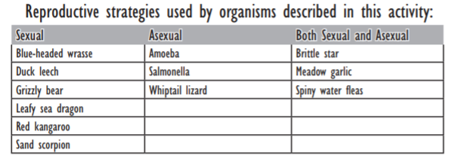
- Instruct each pair to read about their assigned organisms and complete the comparison table on the Investigating Reproductive Strategies worksheet.
- When all pairs have completed the comparison table, have them post their tables around the room.
- Ask students to walk around the room and read the comparison tables with the goal of creating a list of general characteristics for organisms that reproduce sexually and one for organisms that reproduce asexually.
- As a class, compile lists of general characteristics for organisms that reproduce sexually and asexually on the board. Learning objectives and discussion points for each category on the Investigating Reproductive Strategies worksheet are listed on pages 2-4 to help you guide the discussion.
  - Tip: You may wish to have students record their ideas on a sheet of paper while they read the comparison tables.
- Ask students to discuss the advantages and disadvantages of each mode of reproduction in their pairs. Have them prepared to support their reasoning.
- Add advantages and disadvantages to the list of general characteristics for each mode of reproduction.
- Lead a discussion on the types of situations or conditions in which each mode of reproduction would be most advantageous or disadvantageous. Do students think one reproductive mode is generally better? Why?

Formative Assessments: Link the items in the Activities that will be used as formative assessments.

- 1.2.4a Investigating Reproductive Strategies
  - student pages
  - class discussion

Summative Assessments: These are optional; there may be summative assessments at the end of a set of Activities or only at the end of the entire Unit.

- Post-Assessment (given at the end of the unit)
- Group Presentations with rubric (at the end of the unit)

Differentiation: Describe how you modified parts of the Lesson to support the needs of different learners.
Refer to Activity Template for details.
- Place students in small heterogeneous groups (3-4) if possible or groups based on their leadership skills.
- Encourage students to ask their peers before asking a teacher.
- Read alouds

Reflection: Reflect upon the successes and shortcomings of the lesson.

Name: Marie Pollitt | Contact Info: pollittmarie@gmail.com | Date: 6-20-18

Lesson Title : Bioremediation | Unit #:  1 | Lesson #:  2 | Activity #:  5
Activity Title: Introduction of Challenge & Big Idea

Estimated Lesson Duration: | 8-9 days (70 minutes)
Estimated Activity Duration: | 4-5 days (70 minutes)

Setting: | 8th grade classroom

Activity Objectives:
Students will design a plan to safely clean up the ash ponds at Beckjord.
Activity Guiding Questions:
- What is the problem?
- What are the available materials?
- What are the criteria and constraints?
- How will we design a plan?
- What kinds of pollutants are in the ash ponds at Beckjord?
- How do you safely clean up the ash ponds?
- What kinds of organisms clean up pollutants in ash ponds?
- What do these organisms need in order to survive?
- How do these organisms reproduce?
- What are the positive and negative impacts on the when we introduce the new organism to environment?
- What types of mutations can occur in the organism?
- How will we present our design?

Next Generation Science Standards (NGSS)
Science and Engineering Practices (Check all that apply) | Crosscutting Concepts (Check all that apply)
☒ Asking questions (for science) and defining problems (for engineering) | ☐ Patterns
☐ Developing and using models | ☒ Cause and effect
☐ Planning and carrying out investigations | ☐ Scale, proportion, and quantity
☐ Analyzing and interpreting data | ☐ Systems and system models
☒ Using mathematics and computational thinking | ☐ Energy and matter: Flows, cycles, and conservation
☒ Constructing explanations (for science) and designing solutions (for engineering) | ☐ Structure and function.
☐ Engaging in argument from evidence | ☒ Stability and change.
☒ Obtaining, evaluating, and communicating information

Ohio’s New Learning Standards for Science (ONLS)
Expectations for Learning - Cognitive Demands (Check all that apply)
☒ Designing Technological/Engineering Solutions Using Science concepts (T)
☒ Demonstrating Science Knowledge (D)
☒ Interpreting and Communicating Science Concepts (C)
☒ Recalling Accurate Science (R)

Common Core State Standards -- Mathematics (CCSS)
Standards for Mathematical Practice (Check all that apply)
☐ Make sense of problems and persevere in solving them | ☐ Use appropriate tools strategically
☐ Reason abstractly and quantitatively | ☐ Attend to precision
☐ Construct viable arguments and critique the reasoning of others | ☐ Look for and make use of structure
☐ Model with mathematics | ☐ Look for and express regularity in repeated reasoning

Unit Academic Standards (NGSS, ONLS and/or CCSS):
Topic: Species and Reproduction
Standard: This topic focuses on continuation of the species.
Content Statements:
- 8.LS.1: Diversity of species occurs through gradual processes over many generations. Fossil records provide evidence that changes have occurred in number and types of species.
- 8.LS.2: Reproduction is necessary for the continuation of every species.

Materials: (Link Handouts, Power Points, Resources, Websites, Supplies)
- Computers
- 1.2.5a Engineering Design Process (EDP) Graphic Organizer
- 1.2.5b Presentation rubric for Powerpoint/Google Slide

Teacher Advance Preparation:
- Have students in teams
- Provide computers for research
- Print handouts
  - 1.2.5a Engineering Design Process (EDP) Graphic Organizer
  - 1.2.5b Presentation rubric

Activity Procedures:
- Pass out 1.2.5a Engineering Design Process (EDP) Graphic Organizer
- Students begin the Engineering Design Process by...
  - Identify & Define the Problem section on the graphic organizer.
    - Students developed the essential question and challenge in the beginning of the unit.
    - Students will help develop the criteria, constraints, and available materials list.
  - Gather Information
    - Students will research if there are any existing ideas that can help you in your plan such as toxins in ash ponds. Is there any information you learned during the investigations that may help you solve the challenge? Identify any questions you still need to find answers to that may help you solve the challenge.
      - Students will research the different types of pollutants at a specific power plant (Beckjord). They will devise a plan that will use a living organism to remove one of the pollutants from the ash ponds.
  - Identify Alternatives
    - Use the information gathered during the investigations and research to brainstorm possible solutions. List, describe, and/ or sketch and label at least four plans for your process. When developing your solutions, keep in mind the criteria and constraints. You may use additional paper if needed.
    - Use the team’s plan to develop the process by doing the necessary research to solve the challenge.
  - Select Solution
    - Team members will take turns sharing their ideas for the plan. Together as a team, decide on three possible processes to consider further. After all three processes are developed, complete the Pros and Cons section.
  - Implement Solution
    - As a team, choose one particular process to research further. Provide an explanation (claims, evidence and reasoning) of why you choose this particular process. Be sure to include what type of resources your team will use, how the team will document your sources, roles for each team member.
  - Evaluate
    - This is where you will support the team’s process. Provide an overview of the organism being used, its reproductive process, positive and negative ramifications of introducing the species to the environment, as well as identify any mutations that may occur. Provide a safety plan for proper disposal of the organism introduced to the environment.
      - In order to be successful, the organism(s) chosen to clean may or may not have variation in the species. It will depend on the pros and cons of the introduction of the species; for example, if it will be invasive to the environment.
      - They have to justify if the practice of using the organism is an environmentally safe practice.
        - Provide the positives and negatives of introducing the new organism to the surrounding environment.
        - Identify typical mutations that occur in the species.
      - Provide a safety plan for proper disposal of the organism they introduced to the environment.
        - May have to introduce another organism. The organism may or may not have diversity in the species.
      - May use chemical or physical changes to safely remove the organism from the environment.
  - Communicate Solution (Part 1: Reflection)
    - EDP Graphic Organizer
      - Communicate Solution: What changes could you make to your design next time? What successes did you have during your challenge? What were some challenges you faced and how did you address them.
  - Communicate Solution (Part 2: Presentation)
    - Group Presentation
      - Students will create a sales pitch to the EPA discussing how their solution will help clean up aftermath of the power plant. They will need to incorporate Google Slides or PPT during the pitch.
      - The Google Slides or PPT should include the following components:
        - Company Name and Employees’ Names
        - Pollutant they are removing;
        - Research collected that supports using the organism that will remove the pollutant with appropriate citation;
        - Organism being introduced to the environment;
        - Overview of the organism being introduced;
        - Organism’s reproductive process;
        - Positive and negatives ramifications of introducing the organism to the environment;
        - Possible mutations that could occur;
        - Detailed safety plan for proper disposal of the organism they introduced to the environment.
        - Careers in Environmental Remediation
          - Include a description, salary (range and median), and training/education needed.
- Students will deliver a presentation to the class.
- As groups are presenting, have students provide feedback using 1.2.5b Slide Presentation Rubric for each group.
  - All students will provide feedback. It may be easier if each team assigns sections to each team member.
    - Eliminate enough copies of the rubric for a class set.
    - With the eliminated rubric and a dry erase marker, students can complete their portion of the rubric for the team presenting.
    - Once the group is finished presenting, the teams can transfer their section onto the printed rubric.
    - Each team should receive one completed rubric per team in the class.
- After all students have presented and received feedback. Introduce the refine portion of the EDP. The teams will be given the following situation:
  - Your company is unable to use the current organism for clean up due to a shortage. The company will need to provide an alternative solution to complete the job.
    - The new organism being used must clean-up the same toxins as the previous organism.
    - Be sure to provide the same information that was required before.
    - Add additional slides to the presentation.
    - Present again and include the new information as well as any feedback received from your peers.

Formative Assessments: Link the items in the Activities that will be used as formative assessments.

- 1.2.5a Engineering Design Process Graphic Organizer
- 1.2.5b Slide Presentation Rubrics (Student Feedback section)

Summative Assessments: These are optional; there may be summative assessments at the end of a set of Activities or only at the end of the entire Unit.

- 1.1.1a Post-Assessment
- 1.2.5b Slide Presentations Rubric

Differentiation: Describe how you modified parts of the Lesson to support the needs of different learners.
Refer to Activity Template for details.
- Place students in small heterogeneous groups (3-4) if possible or groups based on their leadership skills.
- Encourage students to ask their peers before asking a teacher.
- Developed graphic organizers for the students to use during research and for presentation information.
- Give students sentence starters for each section.
- Assign sections of the slides to students.
- Create a general slide layout for students. You may insert comments on the slides for students to use as guides.

Reflection: Reflect upon the successes and shortcomings of the lesson.

